**Project Report on**

**ONLINE AUCTION PLATFORM**



Submitted by

**SWARNENDU CHAKRABORTY (12022002016042) SUDARSAN DATTA (12022002016016)**

Under the supervision and guidance of

**Dr.Deepsubhra Guha Roy.**

Associate Professor, Department of CSE (AIML), Institute of Engineering and Management (IEM), Kolkata, Salt Lake, India.

PROJECT REPORT SUBMITTED IN PARTIAL FULFILLMENT OF THE

REQUIREMENTS FOR THE FIFTH SEMESTER

**Academic Year: 2022-26**

**Submitted to**

**INSTITUTE OF ENGINEERING AND MANAGEMENT, KOLKATA**



**DEPARTMENT OF COMPUTER SCIENCE AND ENGINEERING (ARTIFICIAL INTELLIGENCE AND MACHINE LEARNING)** **INSTITUTE OF ENGINEERING AND MANAGEMENT, KOLKATA**



1. **CERTIFICATE OF RECOMMENDATION**

We hereby recommend that the project prepared under our supervision by

SWARNENDU CHAKRABORTY **,** SUDARSAN DATTAentitled <ONLINE AUCTION PLATFORM> be accepted in partial fulfillment of the requirements for the degree of partial fulfillment of the fifth semester.

_____________________________ ______________________

Head of the Department Project Supervisor

CSE(AIML),IEM, Kolkata

**DEPARTMENT OF COMPUTER SCIENCE AND ENGINEERING (ARTIFICIAL INTELLIGENCE AND MACHINE LEARNING)** **INSTITUTE OF ENGINEERING AND MANAGEMENT, KOLKATA**



**DECLARATION**

We Swarnendu Chakraborty, Sudarsan Datta, hereby declare that this project report entitled “Online Action Platform” which is being submitted to Institute of Engineering and Management (IEM), Kolkata , in partial fulfilment of the requirements for the fifth semester is an authentic record of our genuine work done under the guidance of Dr.Deepsubhra Guha Roy, Associate Professor, Department of CSE (AIML), Institute of Engineering and Management (IEM), Kolkata, Salt Lake, India, during the academic year 2022-2026.

SWARNENDU CHAKRABORTY [12022002016042]

SUDARSAN DATTA [12022002016016]

Date:………………………….

Place:……………………………

**ACKNOWLEGDEMENT**

We would like to sincerely thank all the people directly or indirectly involved in this project without whose help the completion of this project would have been impossible.

I would like to express my sincere gratitude to my DBMS faculty Dr.Deepsubhra Guha Roy sir who in spite of his busy schedule took keen interest in giving me all the necessary information for developing a good project and for his unlisted encouragement and timely support till my successful completion of the project work.

We thank Deepsubhra sir who has guided us and provided support and genuine replies to our queries. He has not only guided us in the project but also helped us by providing suggestions without which we couldn’t improve at work. HIS certain suggestions and interest in helping us complete the project has led me to the successful result of my project and also all the other Lecturers and lab instructors who had been more of a support to us than ever.

We thank whole heartedly to our beloved Prof. Amartya Mukherjee, Head of CSE(AIML) for granting permission to undertake the project.

Finally, we thank to our parents, who were there by us, financially supported throughout the project and provided the support we needed throughout my life.

INDEX

1. SYNOPSIS …………………………………………………….. 11

1.1 Title of the Project ……………………………………… 11

1.2 Objective of the Project…………………………………. 11

1.3 Project Category………………………………………… 11

1.4 Language(s) to be used…………………………………...11

1.5 HARDWARE AND SOFTWARE REQUIREMENTS.... 11

1.6 LANGUAGES TO BE USED…………………………... 11

1.7 STRUCTURE OF THE PROGRAM ………………....... 12

1.7.1 ANALYSIS ……………………………….……...…... 12

1.7.2 MODULE DESCRIPTION ……………………..……. 12

1.7.3 DATA STRUCTURES ……………………..……….... 12

1.8 LIMITATIONS …………………………………...…….. 13

1.9 FUTURE SCOPE …………………………………....….. 13

2. SOFTWARE REQUIREMENTS SPECIFICATION……….….. 15

2.1 Introduction………………………………………….…... 15

2.2 Purpose…………………………………………….…..… 15

2.2.1 Scope………………………………………………....... 15

2.2.2 Definitions, Acronyms and Abbreviations………..….... 16

2.2.3 References………………………………………..…...... 16

2.2.4Overview……………………………………………....... 16

2.3 Overall description……………………………………….. 16

* 1. Product Perspective………………………………..……… 16

2.5 Product Features……………………………………..…….16

2.6 User classes and characteristics………………………...… 16

2.7 Design and implementation constraints………………....... 17

2.8 Assumptions and Dependencies……………..……….…... 17

2.9 Specific requirements……………………….…………… 17

2.9.1 External Interface Requirements…………….……..….. 17

* + 1. User Interfaces………………………………..………. 18

2.10Hardware Interfaces…………………………….…….… 18

2.11Software Interfaces……………………………….…..…. 18

2.12 Communication Interfaces………………………..…….. 18

2.13Functional Requirements…………………………..…..... 18

2.14 Document conventions……………………………...….. 21

2.15 Intended users and Reading suggestions……………...... 21

2.16 System features……………………………………….... 21

2.17Other non-functional Requirements…………………..... 21

2.17.1 Performance Requirements……………………….…. 21

2.17.2 Safety Requirements………………………………… 22

2.17.3 Security Requirements………………………………. 22

2.17.4 Software quality attributes………………………....... 22

3. SYSTEM DESIGN……………………………………………… 23

3.1 Introduction………………………………………….….. 24

3.2 System Context Diagram……………………………...... 24

3.3 Data Flow Diagram………………………………….….. 24

3.3.1 DFD for Level 1 Admin…………………………….… 25

3.3.2 DFD for Level 1 Customer………………………….… 26

3.3.3 DFD for Level 2 Customer…………………….……… 27

3.3.4 DFD for Level 1 Employee…………………………… 28

4.DATABASE DESIGN…………………………………………... 30

4.1 INTRODUCTION………………….…………………... 30

4.1.1. Internal level…………………………………………. 30

4.1.2. Conceptual level …………………………………….. 30

4.1.3. External level ………………………………………... 30

4.2. WHAT IS DATABASE……………………………….. 30

4.3. DATABASE DESIGN………………………………… 31

4.4. TABLE STRUCTURE………………………………… 32

4.5. ENTITY RELATIONSHIP DIAGRAM ……………… 36

4.5.1 ER Diagram……………………………...…………… 38

5.DETAILED DESIGN…………………………………..………..40

5.1 Introduction………………………………..…………... 40

5.2 Applicable documents…………………...……………... 40

5.3 Structure of the software package…...…………………. 40

5.4 STRUCTURE CHART OF ADMIN…...……………... 42

5.5 STRUCTURE CHART OF Employee………………… 42

5.6 STRUCTURE CHART OF Customer…………………. 43

5.7 Modular Decomposition Of Components………………. 43

5.8 Customer Account Component…………………………. 44

5.9. Product list Component……………………………..…. 44

5.10. Category Component……………………………….…. 45

5.11. Search Component…………………………………….. 46

5.12 Bidding Component……………………………………. 46

5.13. Purchase Component……………………………….….. 47

5.14. Chat Component…………………………………......... 48

5.15 Report Component…………………………………....... 48

5.16. Dashboard Component………….……………………... 49

5.17. Settings Component………………………………….... 50

6.CODING………………….……………...……............................. 52

6.1 Introduction……………...………….……….................... 52

6.2 Programming practices……..………….………………… 53

6.3 Coding for Register…………………...………………...... 54

6.4 Validation For Category…………………………………. 62

6.5 Coding for Category…………….....…………………….. 65

7.TESTING…………………………………………......................... 74

7.1 Introduction……………………………………................. 74

7.2 Levels of Testing……………………..………………....... 74

7.3 Test Reports………………………….…………............... 75

8.SCREEN SHOTS……………………………………………......... 93

9.USER MANUAL……………………………………….……........ 119

9.1 Software Interfaces…………………………........………. 119

9.2 User classes and characteristics……………..…..……….. 119

9.3 Design and implementation constraints…..…………….... 119

9.4 Functional Requirements………………..……………….. 120

10. CONCLUSION………………………………………...……….. 124

11. FUTURE ENHANCEMENT…………………………………… 126

12. BIBLIOGRAPHY………………………………………………. 128

**CHAPTER-1**

**SYNOPSIS**

**1. PROJECT SYNOPSIS**

**1.1 Title of the Project**

Online Auction Platform

**1.2 Objective of the Project**

Online Auction is the website application in where participant scan bid for the

products. In online auction project that holds online auctions of various products on

a website and serves sellers and bidders accordingly. The system is designed to allow

users to setup their products for auctions and bidders to register and bid for various

products available for bidding.

**1.3 Project Category**

Web application (Research/Education related)

**1.4 Language(s) to be used**

HTML, CSS, Java Script, AJAX, Bootstrap, PHP, SQL

**1.5 HARDWARE AND SOFTWARE REQUIREMENTS**

**1.5.1 HARDWARE REQUIREMENTS**

* Processor - Intel Pentium IV
* Processor Speed – 1.40 GHz
* RAM – 2 GB or above.
* Monitor resolution - A colour monitor with minimum resolution of 1000*700

**1.5.2 SOFTWARE REQUIREMENTS**

* IDE : AdobeDreamweaverCS6.0
* Front-end: PHP 5.2
* Back-end: MySQL Server 5.1.1

**1.6 LANGUAGES TO BE USED**

**1.6.1 FRONT END**

HTML, CSS, BOOTSTRAP

**1.6.2 BACK END**

PHP, MYSQL

**1.7 STRUCTURE OF THE PROGRAM**

**1.7.1 ANALYSIS:** An efficient code will be implemented which will support majority of the browsers and their resolution constraints. It will be ensured to consume less time for its execution. The code will be well structured with easy to understand format and separate file for both front end and back end codes.

**1.7.2 MODULE DESCRIPTION**

**LOGIN/REGISTRATION MODULE:** Those who wish to take part in

Bidding or sell products at the site have to register at the site as customer. Only

authenticated users can take part in selling or in bidding. In this module

customer can register to the system by entering registration details. After the

registration they can login to the system by entering unique login id and

password.

* **CUSTOMER MODULE:** In the customer module customer can view his own bidding details, Purchase report, auction winning report, etc.
* **PRODUCT LIST MODULE:** This collects information like product name,

product detail, product image, Start bid, Sale price, Bidding start date and end date.

* **CATEGORY MODULE**: Before uploading product Customer should select category details. In the website product displays under the category list.
* **SEARCH MODULE:** In this module customer can search for particular products.
* **BIDDING MODULE**: In the bidding module customer can bid for products Customer can select any item and they can bid for the product.
* **PURCHASE MODULE:** This module is for winning bids where customer

can pay for winning bids. After the payment seller needs to deliver the product to customer.

* **CHAT MODULE:** If the customer has any queries regarding product they

can directly contact with sellers. 24x7 online chat features available. If the

seller is offline then the message stores under seller message box.

* **REPORT MODULE**: This module is for administrator to check sales report,

product report, auction report, payment report, etc.

* **DASHBOARD MODULE:** This dashboard module is for administrator and

employees. Admin has full authority of the website and employee has limited

authority.

* **SETTINGS MODULE:** Here administrator can add employees, categories,

website settings, etc.

**1.7.3 DATA STRUCTURES**

All the data related to student and guide will be stored in a well-structured manner using MySQL database. The research papers will also be stored as a file.

**1.8 LIMITATIONS**

The research papers have privacy issues related to it. So a higher level of security must be ensured to the system.

**1.9 FUTURE SCOPE**

* In future we can integrate this web application with mobile apps.
* We can add gaming bid features in future.
* Currently this system supports India rupee currency. In future upgradation we can add multiple currencies.
* We can Add bidding system for Agriculture produces which helps farmers to sell for best auction price.
* We can add GPS features where buyer can track seller location

**CHAPTER-2**

**SOFTWARE REQUIREMENTS**

**SPECIFICATIONS**

**2. SOFTWARE REQUIREMENTS SPECIFICATION**

* 1. **Introduction:**

A **software requirements specification** (SRS) is a description of a [software system](https://en.wikipedia.org/wiki/Software_system) to be developed, laying out [functional](https://en.wikipedia.org/wiki/Functional_requirement) and [non-functional requirements](https://en.wikipedia.org/wiki/Non-functional_requirements), and may include a set of [use cases](https://en.wikipedia.org/wiki/Use_case) that describe interactions the users will have with the software.

A basic purpose of the SRS is to bridge this communication gap between client and the developer so they have a shared vision of the software being built. An SRS establishes the bas is for agreement between the client and the supplier on what the software product will do. SRS provides a reference for validation of the final product. A high-quality SRS is a prerequisite to high-quality software and also reduces the development cost.

The introduction of the Software Requirements Specification (SRS) provides an overview of the entire SRS with purpose, scope, definitions, acronyms, abbreviations, references and overview of the SRS. The aim of this document is to gather and analyze and give an in-depth insight of the complete “Online Auction” by defining the problem statement in detail. The detailed requirements of “Online Auction” are provided in this document.

**2.2 Purpose:**

This Document includes software requirements for the “Online Auction” Project. The purpose of this document is to detail the user requirements for all the functionality in “Online Auction”. This document is meant to serve as a guide to the developers and users. The purpose of the requirement document is to specify and provide all the information required to design, develop and test the system. This document ensures that the person reading the document understands what she/he is looking for.

Online Auction is the website application in where participants can bid for the products. In online auction project that holds online auctions of various products on a website and serves sellers and bidders accordingly. The system is designed to allow users to set up their products for auctions and bidders to register and bid for various products available for bidding.

**2.2.1 Scope:**

This project has following features and scopes:

* This auction website works online. The bidder and seller can participate in auction from anywhere at any time through online auction.
* Those who wish to take part in bidding or sell products at the site have to register at the site as customer. Only authenticated customers can take part in selling or in bidding.
* Customer can see the profile of the bidding history of items which are still open. Similarly the seller can see the progress of bidding.
* Auction winners and losers get an Email notification whether they won or lost the bid.

**2.2.2 Definitions, Acronyms and Abbreviations:**

* **SRS:** Software Requirements System
* **OS:** Operating System
* **PHP:** PHP: Hypertext Pre-processor
* **PC:** Personal Computer
* **MB:** Mega Bytes
* **RAM:** Random Access Memory
* **MySQL:** MySQL database Server

**2.2.3References:**

* www.w3schools.com
* www.tutorialspoint.com
* www.stackoverflow.com
* Web Database Applications with PHP and MySQL By Hugh E. Williams, ‎David Lane
* An integrated approach to Software Engineering By Pankaj Jalote

**2.2.4Overview:**

This SRS will allow for a complete understanding of what is to be expected of the “Online Auction” web application to be constructed. The clear understanding of the “Online Auction” System and its functionality will allow for end users and will be used for the development of the future stages of the project.

**2.3 Overall description:**

This section of the SRS describes all general factors of the product and its requirements. This SRS explains detailed requirements of Online Auction website application.

**2.4 Product Perspective:**

Current developing project is the web application project developing using PHP. This system is developed using PHP and all the record stores in the MySQL database.

**2.5 Product Features**:

This product has following features:

* Administrator or Customers of the site can login and add auction items so user can search and view details of auction items with images, product title and auction date / time.
* No registration required to view Auction product information.
* There are 2 types of users in this system: Customer and Employees. Admin and staff are the sub users comes under employee.
* Administrator can view all features of the website.

**2.6 User classes and characteristics:**

There are 2 types of users using for this system.

* **Customer:**

The Public user can view all the website features. The customer or seller need to create a account to participate in the auction website. The customer needs to login to the system for bidding.

* **Employee:**

Employees are the website owners who manages complete website. There are two main users under the employee i.e; admin and employee. Admin has full authority of the website and employee has limited authority.

**2.7 Design and implementation constraints:**

The developed system should run under any platform (Unix, Linux, Mac, Windows etc.) that contains a web browser which supports PHP, JavaScript and AJAX.

* Internet connectivity is required to send mails.
* The user who is accessing the system should be authorized.
* MySQL database is the backend of the system.
* The system needs following tables under online auction database.
* Billing
* Bidding
* Category
* Customer
* Employee
* Message
* Payment
* Product
* winners

**2.8 Assumptions and Dependencies:**

* The users should have basic knowledge of the computers. They must be trained well to handle the features provided by this system.
* Some of the details are required to be entered by the user and may not be generated automatically.
* Administrator is created in the system already.
* Roles and tasks are predefined.

**2.9 Specific requirements:**

**2.9.1 External Interface Requirements:**

This chapter is an outline of the inputs and outputs of the project.

**2.9.2 User Interfaces:**

Each part of the user interface intends to be as user friendly as possible. The fonts and buttons used will be intended to be very fast and easy to load on web pages. The pages will be kept light in space so that it won’t take a long time for the page to load.

**2.10 Hardware Interfaces:**

* **Operating System:** Unix, Linux, Mac, Windows etc.
* **Processor:** Pentium or Higher.
* **RAM:** 312MB or Higher.14” monitor
* Keyboard and mouse

**2.11 Software Interfaces:**

* **Development tool:** PHP : Hypertext Pre-processor, JavaScript, Ajax
* **Scripting server:** Apache server
* **Data Base server:** MySQL
* **IDE:** Adobe Dreamweaver CS 6.0 / Notepad++

**2.12 Communication Interfaces:**

Internet connection must required.

**2.13 Functional Requirements:**

**2.13.1 Login/Registration module:**

Those who wish to take part in bidding or sell products at the site have to register at the site as customer. Only authenticated users can take part in selling or in bidding. In this module customer can register to the system by entering registration details. After the registration they can login to the system by entering unique login id and password.

This module has following sub modules:

* Login module
* Registration module

**2.13.2 Customer account module:**

In the customer account module customer can view his own bidding details, Purchase report, auction winning report, etc. Even the customer can change his password and he can update the password in the account section.

This module has following sub modules:

* Customer account
* Customer profile
* Change password
* Update profile
* View bidding details
* View auction records

**2.13.3 Product list module:**

This module allows sellers to add auction products. This collects information like product name, product category, product detail, product image, Start bid, Sale price, Bidding start date and end date from seller.

This module has following sub modules:

* Add product
* Product list module
* Update product
  + 1. **Category module:**

Before uploading product Customer should select category details. In the website product displays under the category list. Only administrator can add category records.

This module has following sub modules:

* Add category
* View category
  + 1. **Search module:**

In this module customer can search for particular products. After searching the system display records in the search list.

This module has following sub modules:

* Search product list
* View product list
  + 1. **Bidding Module:**

In the bidding module customer can bid for products. Customer can select any item and they can bid for the product.

This module has following sub modules:

Product Bidding module

* View bidders
* View bidding records
  + 1. **Purchase module:**

This module is for winning bids where customer can pay for winning bids. After the payment seller needs to deliver the product to customer.

This module has following sub modules:

* Purchase product
* View purchase detail
  + 1. **Chat module:**

If the customer has any queries regarding product they can directly contact with sellers. 24x7 online chat features available. If the seller is offline then the message stores under seller message box.

This module has following sub modules:

* Compose message
* View sent messages
* View Received messages
  + 1. **Report module:**

This module is for administrator to check sales report, product report, auction report, payment report, etc.

This has following sub modules

* View customers
* View messages
* View bidding items
* View winners list

**2.13.10 Dashboard module:**

This dashboard module is for administrator and employees. Admin has full authority of the website and employee has limited authority.

This module has following sub modules:

* View dashboard
* View profile
* Update profile
* Change password
  + 1. **Settings module:**

Here administrator can add employees, categories, website settings, etc.

* Add employees
* View employees
* Add category
* View category

**2.14Document conventions:**

The format of this SRS is simple. Bold face and indentation is used on general topics and or specific points of interest. The remainder of the document will be written using the standard font New Times Roman.

**2.15 Intended users and Reading suggestions:**

This document is intended for software developers, document writers and for general discussions on the implementation decisions regarding the software.

**2.16 System features:**

The coding is done with following characteristics in mind:

* Ease of design to code translation
* Code efficiency
* Memory efficiency
* Response time
* Maintainability
* Security
* Simple ease to understand code
* Efficient and consistent logic
  1. **Other non-functional Requirements:**

**2.17.1 Performance Requirements:**

Performance requirements define acceptable response times for system functionality.

* The system is supposed to be having good memory space and RAM should be Above 256 MB preferably.
* The sound card and graphics card will have to be of good quality and capacity.
* The load time for user interface screens shall take no longer than three seconds.
* The log in information shall be verified within three seconds.
* Queries shall return results within three seconds.

**2.17.2 Safety Requirements:**

* In case if the customer forget their password, they can recover the password in the Forgot Password panel.
* The password stores in the database in the format of encrypted password.

**2.17.3 Security Requirements:**

* Only authenticated users can access this system.
* Employee and Customer has different interface to increase the security.
  + 1. **Software quality attributes:**
* **Reliability:** This system is designed to have very simple database just to cater the exact need of “Online Auction”. It is tested for all the constraints at development stage.
* **Availability:** This system will only available till the system on which it is installed is running.
* **Security:** This system is provided with authentication without which no user can pass. So only the legitimate users are allowed to use the application. If the legitimate users share the authentication information then the system is open to outsiders.
* **Maintainability:** There is maintenance required for the website. The database is provided by the Administrator as well as the end-use.
* **Portability**: The system works anywhere with the internet connection.

**CHAPTER-3**

**SYSTEM DESIGN**

**3. SYSTEM DESIGN**

**3.1 Introduction**

Design is processes through which requirements are translated into a representation of the software .The purpose of the designing phase is to plan a solution for the problem specified by the requirement document i.e. the requirement are translated into software. The design activities often result in three separate outputs:

1. Architecture Design

2. High Level Design

3. Detailed Design

System Design is a solution a “How to “approach to the creation of a new system. The importance phase is composed of several steps. It provides the understanding of procedural detail necessary for the system recommended in the feasibility study. Emphasis is on translating the performance requirement into design specification

**3.2 System Context Diagram**

The System Context Diagram or Context Flow Diagram (CFD) describes the external entities acting on the system. The environment in which the system is used is depicted in the figure.

**Context Flow Diagram (CFD)**

ONLINE

AUCTION

ADMIN

CUSTOMER

EMPLOYEE

**3.3 Data Flow Diagram**

A Data Flow Diagram (DFD) is a graphical representation of the “flow” of the data through an information System. A DFD also can be used for the visualization of data processing. It is common practice for design to draw a context level DFD first which shows the interaction between the system and outside entities. This context-level DFD is then “exploded” to show more detail of the system being modelled.

**The DFD uses four symbols, and explained below**:

|  |  |
| --- | --- |
| A SQUARE | Which defines the source or destination of system data also called an external entity, is not responsible for any task performed by the System. |
| An ARROW | Represents data flow. It represents the path over which data travels in the system. A data can move between processes,flow into or out of the stores to and from external entities.It must be given a name the arrow head showing the direction of flow |
| CIRCLE | Represents a process that transforms data from one to another by performing some tasks with the data. The process name must be given a general idea of its function |
| HORIZONLPARALLEL LINES | Representsdata store, a data store is place where data is held temporarily from one transaction to the next or is permanently Data Flow Diagram describes what data flow (logical)rather than how they are processed, so it does not depend on hardware, software, data structure or file organization |

**3.3.1 DFD for Level 1 Admin:**

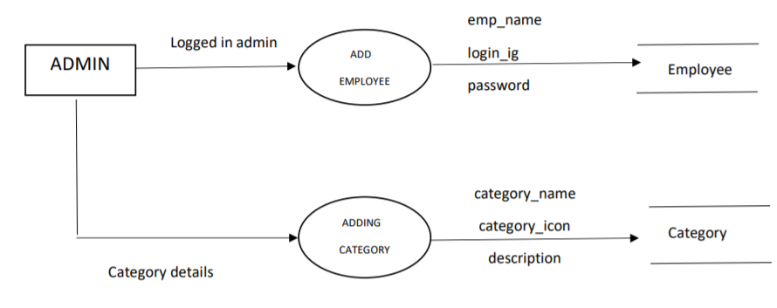

**3.3.2 DFD for Level 1 Customer:**

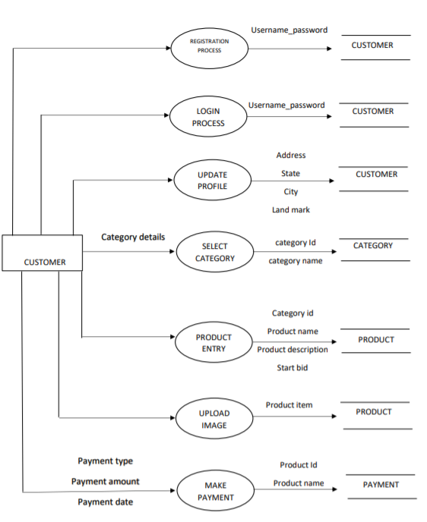

**3.3.3 DFD for Level 2 Customer:**

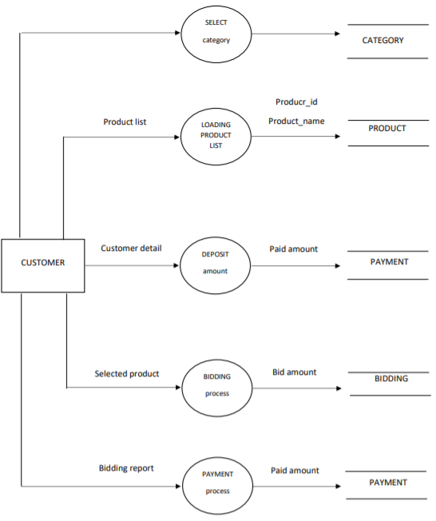

**3.3.4 DFD for Level 1 Employee:**

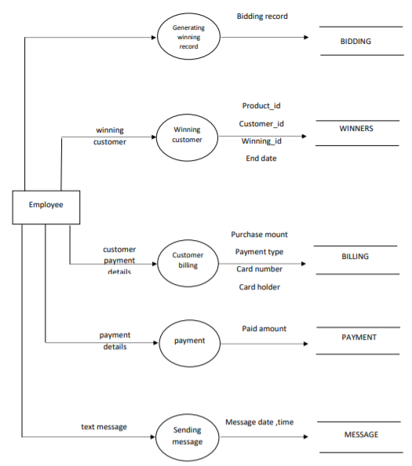

**CHAPTER-4**

**DATABASE DESIGN**

**4.DATABASE DESIGN**

**4.1 INTRODUCTION**

The description of the database is called the database scheme. A database scheme is specified during database creation and is not accepted to change frequently. Most data model has certain conversations for diagrammatically

**4.1.1. Internal level**

displaying scheme. The scheme diagram displays only some aspects of scheme, such aspects are not specified in the scheme diagram that is neither the data type of each data item that change frequently.

The data in the database is particular moment in timer is called a database state.

Schema can be defined in the following three levels.

The internal Level has an internal scheme. It describes the physical storage structure of the database. The internal schema uses a particular data model and describes the complete details of the data storage and access paths of the database.

**4.1.2. Conceptual level**

The conceptual level has conceptual schema, which describes the structure of whole database for a community of users. The conceptual schema hides the details of the physical storage structure and concentrates on describing entities, datatypes relationship user operation and constraints. A high-level data model or an implementation data model can be used in this model.

**4.1.3. External level**

External level or view includes a number of external schema or view. Each internal schema describes the part interested in and hides the rest of the database from the user group. A high level data model or an implementation model can be used at this level.

**4.2. WHAT IS DATABASE?**

A database is an organized collection of data. It is the collection of schemas tables, queries, reports, views, and other objects. The data are typically organized to model aspects of reality in a way that supports processes requiring information. Which can be of any size and complexity. By using the concept of database, we can easily store and retrieve the data. The major purpose of the database is to provide the information, which utilizes data that the system needs according to its own requirements.

**4.3. DATABASE DESIGN**

Database design is the process of producing a detailed data model of database. This data model contains all the needed logical and physical design choices and physical storage parameters needed to generate a design in a data definition language, which can then be used to create a database. A fully attributed data model contains detailed attributes for each entity.

The term database design can be used to describe many different parts of the design of an overall database system. Principally, and most correctly, it can be thought of as the logical design of the base data structures used to store the data. In the relational model, these are the tables and views. In an object database, the entities and relationships map directly to object classes and named relationships. However, the term database design could also be used to apply to the overall process of designing, not just the base data structures, but also the forms and queries used as part of the overall database application within the database management system (DBMS).

To retrieve data from the database;

* The application program determine what data is needed and communication the need to the DBMS.
* The data must be defined in the sub schema.
* The copy of the data is given to the operating system for processing.
* A database, must be created before it can be used.

**4.4. TABLE STRUCTURE**

## 4.4.1Table structure for table bidding

|  |  |  |
| --- | --- | --- |
| **Column** | **Type** | **Null** |
| ***bidding_id*** | int(10) | No |
| customer_id | int(10) | No |
| product_id | int(10) | No |
| bidding_amount | float(10,2) | No |
| bidding_date_time | Datetime | No |
| note | Text | No |
| status | varchar(10) | No |

## 4.4.2. Table structure for table billing

|  |  |  |
| --- | --- | --- |
| **Column** | **Type** | **Null** |
| ***billing_id*** | int(10) | No |
| customer_id | int(10) | No |
| product_id | int(10) | No |
| purchase_date | date | No |
| purchase_amount | float(10,2) | No |
| payment_type | varchar(20) | No |
| card_type | varchar(50) | No |
| card_number | varchar(20) | No |
| expire_date | date | No |
| cvv_number | varchar(5) | No |
| card_holder | varchar(50) | No |
| delivery_date | date | No |
| note | text | No |
| status | varchar(10) | No |

## 4.4.3. Table structure for table category

|  |  |  |
| --- | --- | --- |
| **Column** | **Type** | **Null** |
| ***category_id*** | int(10) | No |
| category_name | varchar(50) | No |
| category_icon | varchar(100) | No |
| description | text | No |
| status | varchar(10) | No |

## 4.4.4.Table structure for table customer

|  |  |  |
| --- | --- | --- |
| **Column** | **Type** | **Null** |
| ***customer_id*** | int(10) | No |
| customer_name | varchar(50) | No |
| email_id | varchar(50) | No |
| password | varchar(100) | No |
| address | text | No |
| state | varchar(25) | No |
| city | varchar(25) | No |
| landmark | varchar(50) | No |
| pincode | varchar(6) | No |
| mobile_no | varchar(15) | No |
| note | text | No |
| status | varchar(10) | No |

## 4.4.5Table structure for table employee

|  |  |  |
| --- | --- | --- |
| **Column** | **Type** | **Null** |
| ***employee_id*** | int(10) | No |
| employee_name | varchar(50) | No |
| login_id | varchar(50) | No |
| password | varchar(100) | No |
| employee_type | varchar(50) | No |
| status | varchar(15) | No |

## 4.4.6Table structure for table message

|  |  |  |
| --- | --- | --- |
| **Column** | **Type** | **Null** |
| ***message_id*** | int(10) | No |
| sender_id | int(10) | No |
| receiver_id | int(10) | No |
| message_date_time | datetime | No |
| product_id | int(10) | No |
| message | text | No |
| status | varchar(10) | No |

## 4.4.7Table structure for table payment

|  |  |  |
| --- | --- | --- |
| **Column** | **Type** | **Null** |
| ***payment_id*** | int(10) | No |
| customer_id | int(10) | No |
| payment_type | varchar(50) | No |
| product_id | int(10) | No |
| bidding_id | int(10) | No |
| paid_amount | float(10,2) | No |
| paid_date | date | No |
| status | varchar(10) | No |

## 4.4.8Table structure for table product

|  |  |  |
| --- | --- | --- |
| **Column** | **Type** | **Null** |
| ***product_id*** | int(10) | No |
| customer_id | int(10) | No |
| product_name | varchar(50) | No |
| category_id | int(10) | No |
| product_description | text | No |
| starting_bid | float(10,2) | No |
| ending_bid | float(10,2) | No |
| start_date_time | datetime | No |
| end_date_time | datetime | No |
| product_cost | float(10,2) | No |
| product_image | varchar(100) | No |
| product_warranty | varchar(100) | No |
| product_delivery | text | No |
| company_name | varchar(100) | No |
| status | varchar(10) | No |

## 4.4.9Table structure for table winners

|  |  |  |
| --- | --- | --- |
| **Column** | **Type** | **Null** |
| ***winner_id*** | int(10) | No |
| product_id | int(10) | No |
| customer_id | int(10) | No |
| winners_image | varchar(100) | No |
| winning_bid | float(10,2) | No |
| end_date | date | No |
| status | varchar(10) | No |

**4.5 ENTITY RELATIONSHIP DIAGRAM**

Entity relationship diagram is used in modern database software. Software engineering is to illustrate logical structure of database. It is a relational schema database, modelling method, used to model a system and approach. This approach is commonly used in database design. The diagram created using this are called entity relationship diagram.

The ER diagram depicts the various relationship among entities, considering each object as an entity. Relationship depicts the relationship between data objects. The ERD is the notation that is used to conduct the data modeling activity.

**Entity**

Entity is a thing, which we want to store information. It is an elementary basic building block of storing information about business process. An entity represents an object desired within the information system abut which u want to store information.

**Relationship**

A relationship is a named connection, associated between entities, or used to relate two or more entities with some common attributes or meaningful interaction between the object.

**Attributes**

Attributes are the properties of entities and relationship. Description of the entity. Attributes are elementary pieces of information attached to an entity.

**Link**

Lines link attributes to entity set and entity sets to relation.

**Cardinality Ratio**

It specifies the maximum number of relationships instances that an entity can participate in. There are four cardinality ratios.

**ER- Diagram Symbols:**

|  |  |  |
| --- | --- | --- |
| **Name** | **Notation** | **Description** |
| Entity |  | It may be an object with the physical existence or conceptual existence. It is represented by a rectangle. |
| Attribute |  | The properties of the entity. Can be attribute. It is represented by a Ellipse. |
| Relationship |  | Whenever an attribute of one entity refers to another entity, some relationship exists. It is represented by a Diamond |
| Link |  | Lines link attributes to entity set and entity sets to relation |
| Cardinality Ratio | 1:1  1:N  N:1  M:1 | It specifies the maximum number of relationships instances that an entity can participate in. There are four cardinality ratios. |

* **4.5.1 ER Diagram**



**CHAPTER-5**

**DETAILED DESIGN**

**5.DETAILED DESIGN**

* 1. **Introduction:**

The purpose of preparing this document is to explain complete design details of Online Auction.

This detailed design report will mainly contain the general definition and features of the project, design constraints, the overall system architecture and data architecture. Additionally, a brief explanation about our current progress and schedule of the project will be provided in related sections. Design of the system and subsystems/modules will be explained both verbally and visually by means of diagrams in order to help the programmer to understand all information stated in this document correctly and easily.

* 1. **Applicable documents:**

The documents used during detailed design are

* System Requirements Document
* System Design
* Database Design
  1. **Structure of the software package**:

The Components are –

* + 1. **Login/Registration module:**

Those who wish to take part in bidding or sell products at the site have to register at the site as customer. Only authenticated users can take part in selling or in bidding. In this module customer can register to the system by entering registration details. After the registration they can login to the system by entering unique login id and password.

* + 1. **Customer account module:**

In the customer account module customer can view his own bidding details, Purchase report, auction winning report, etc. Even the customer can change his password and he can update the password in the account section.

* + 1. **Product list module:**

This module allows sellers to add auction products. This collects information like product name, product category, product detail, product image, Start bid, Sale price, Bidding start date and end date from seller.

* + 1. **Category module:**

Before uploading product Customer should select category details. In the website product displays under the category list. Only administrator can add category records.

* + 1. **Search module:**

In this module customer can search for particular products. After searching the system display records in the search list.

* + 1. **Bidding Module:**

In the bidding module customer can bid for products. Customer can select any item and they can bid for the product.

* + 1. **Purchase module:**

This module is for winning bids where customer can pay for winning bids. After the payment seller needs to deliver the product to customer.

* + 1. **Chat module:**

If the customer has any queries regarding product they can directly contact with sellers. 24x7 online chat features available. If the seller is offline then the message stores under seller message box.

* + 1. **Report module:**

This module is for administrator to check sales report, product report, auction report, payment report, etc.

* + 1. **Dashboard module:**

This dashboard module is for administrator and employees. Admin has full authority of the website and employee has limited authority.

This module has following sub modules:

* + 1. **Settings module:**

Here administrator can add employees, categories, website settings, etc.

* 1. **STRUCTURE CHART OF ADMIN**



* 1. **STRUCTURE CHART OF Employee**



* 1. **STRUCTURE CHART OF Customer**

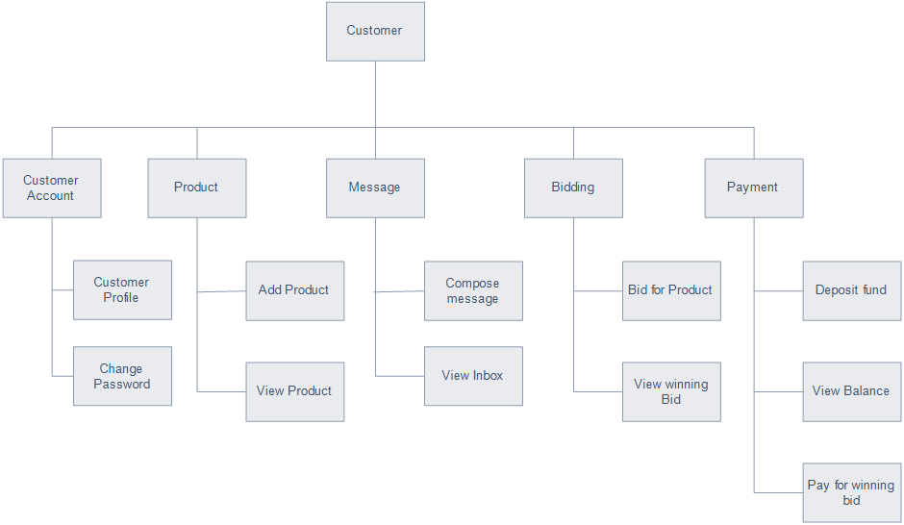

**5.7 Modular Decomposition Of Components:**

**5.7.1 Structure chart for Login/Registration:**



**5.8 Customer Account Component:**

**5.8.1. Identification Of Modules :**

The modules identified in this component are:

* Customer account
* Customer profile
* Change password
* Update profile
* View bidding details
* View auction records

**5.8.2. Structure chart for Customer Account:**



**5.9 Product list Component:**

**5.9.1. Identification Of Modules :**

The modules identified in this component are:

* Add product
* Product list module
* Update product

**5.9.2. Structure chart for Product list:**



**5.10. Category Component:**

**5.10.1. Identification Of Modules :**

The modules identified in this component are:

* Add category
* View category

**5.10.2. Structure chart for Category:**



**5.11. Search Component:**

**5.11.1. Identification Of Modules:**

The modules identified in this component are:

* Search product list
* View product list

**5.11.2. Structure chart for Search:**



**5.12. Bidding Component:**

**5.12.1. Identification Of Modules:**

The modules identified in this component are:

* Product Bidding module
* View bidders
* View bidding records

**5.12.2. Structure chart for Bidding:**



**5.13. Purchase Component:**

**5.13.1. Identification Of Modules :**

The modules identified in this component are:

* Purchase product
* View purchase detail

**5.13.2. Structure chart for Purchase:**



**5.14 Chat Component:**

**5.14.1. Identification Of Modules :**

The modules identified in this component are:

* Compose message
* View sent messages
* View Received messages

**5.14.2. Structure chart for Chat:**



**5.15. Report Component:**

**5.15.1. Identification Of Modules:**

The modules identified in this component are:

* View customers
* View messages
* View bidding items
* View winners list

**5.15.2. Structure chart for Report:**



**5.16. Dashboard Component:**

**5.16.1. Identification Of Modules :**

The modules identified in this component are:

* View dashboard
* View profile
* Update profile
* Change password

**5.16.2. Structure chart for Dashboard:**



**5.17. Settings Component:**

**5.17.1. Identification Of Modules :**

The modules identified in this component are:

* Add employees
* View employees
* Add category
* View category

**5.17.2. Structure chart for Settings:**



**CHAPTER-6**

**CODING**

**6.CODING**

**6.1 Introduction:**

The goal of coding or programming phase is to translate the system design, produced during the designing phase, into code in a given programming language which can be executed by a computer and that performs the computation specified by the design. During the implementation, it should be kept in mind that the programs should not be constructed so that they are easy to write, but that they are easy to read and understand.

**6.2 Programming practices:**

**6.2.1 Top-down & Bottom-up approaches:**

In a top-down implementation, the implementation starts from the top of the hierarchy and proceeds to the lower levels. First the main module is implemented, and their subordinates, and so on. In a bottom-up implementation, the process is the reverse. The development starts with implementing the modules at the bottom of the hierarchy and proceeds through the higher levels until it reaches the top.

Top-down and bottom-up implementation should not be confused with top-down and bottom-up design, here the design is being implemented, and if the design is fair detailed and complete, its implementation can proceed in either the top-down manner.

**6.2.2 Structured Programming:**

The basic objective of the coding activity is to produce programs are easy to understand. A program has a static structure as well as a dynamic structure. The static structure is the structure of the text of the program, which is usually just a line organization of statements of the program. The dynamic structure of the program is the sequences of statements executed during the execution of the program.

In other words both the static structure and the dynamic behavior are sequences of statements; when the sequence representing the static structure is fixed, the sequences of statements it executable can change from execution to execution.

**6.2.3 Information Hiding:**

A software solution to a problem always contains data structures that are meaningfully represent information in the problem domain. That is, when software is developed results a problem, the software uses some data structures to capture the information in the problem domain. Any software solution to a problem contains data structures that represent information in the problem domain. In the problem domain, in general, only certain operations are performed on some information. That is, a piece of information in the problem domain is used only in a limited number of ways in the problem domain.

**6.2.4 Programming style:**

Here we will list some general rules that can be applied for writing good code.

* **Names:** Selecting module and variable names is often not considered important novice programmers. Most variable sin a program reflects some entity in the problem domain, and the modules reflect some process. Variable names should be closely related to the entity they represent, and module names should reflect their activity.
* **Control constraints:** As discussed earlier, it is desirable that as much as possible single entry, single exit constructs be used. It is also desirable to use a few standard control constructs rather than using a wide variety of constructs, just because they are available in the language.
* **Information hiding:** As discussed earlier, information hiding should be supported where possible. Only the access functions for the data structures should be made visible while hiding the data structures behind these functions.
* **User-defined types:** Modern languages allow users to define data types when such facilities are available, they should be exploited where applicable.
* **Nesting:** The different control constructs, particularly the if-then-else, can be nested.
* If the nesting becomes too deep, the programs become harder to understand. In case of deeply nested if-then-elses, it is often difficult to determine if statement to which a particular else clause is associated. If possible, deep nesting should be avoided.

**6.2.5 Verification:**

Verification of the output of the coding phase is primarily interested for detecting errors introduced during this phase. That is, the goal of verification of the code produced is to show that the code is consistent with the design is supposed to implement. It should be avoided out that by verification we mean providing correctness of programs. Program verification method falls into two categories- static and dynamic methods.

In dynamic methods, the program executes some test data and the outputs of the program are examined to determine if there are any errors present.

Static techniques, on the other hand, do not involve actual program execution on actual numeric data, though it may involve some form of conceptual execution:

**6.2.5.1 Code Reading:**

Code reading involves careful reading of the code by the programmer to detect any discrepancies between the design specifications and the actual implementation. It involves determining the abstraction of a module and then comparing it with its specifications. The process of code reading is best done by reading the code inside-out, starting with the innermost structure of the module. First determine its abstract behavior and specify the abstraction. Then the higher level structure is considered, with the inner structure replaced by its abstraction. This process is continued until we reach the module or program being read.

**6.2.5.2 Static analysis:**

Analysis of programs by methodically analyzing the program text is called static analysis is usually performed mechanically by the aid of software tools. During static analysis the program itself is not executed, but the program text is the input to the tools. The aim of the static analysis tools is to detect errors or potential errors or to generate information about the structure of the program that can be useful for documentation or understanding of the programs. An advantage is that static analysis sometimes detects the errors themselves, not just the presence of errors as in testing. This saves the effort of tracing the error from the data that reveals the presence of errors. Static analysis can provide insight into the structure of the program.

**6.2.5.3 Symbolic execution:**

Inputs to the program are not numbers but symbols representing the input data, which can take different values. The execution of the program proceeds like normal execution, except that it deals with values that are not numbers but formulates consisting of the symbolic input values. The outputs are symbolic formulae of input values. These formulae can be checked to see if the program will behave as expected. This approach is called as symbolic execution.

**6.3 Coding for Register:**

<?php

include("header.php");

if(isset($_POST['submit']))

{

$sql ="INSERT INTO customer(customer_name,email_id,password,mobile_no,status) values('$_POST[customer_name]','$_POST[email_id]','$_POST[password]','$_POST[mobile_no]','Active')";

$qsql = mysqli_query($con,$sql);

if(mysqli_affected_rows($con) == 1)

{

echo "<script>alert('Customer Registration done successfully..');</script>";

echo "<script>window.location='customerlogin.php';</script>";

}

else

{

echo "<script>alert('Failed to Register..');</script>";

echo mysqli_error($con);

}

}

?>

<!-- breadcrumb-area start -->

<div class="breadcrumb-area bg-gray">

<div class="container-fluid">

<div class="row">

<div class="col-lg-12">

<ul class="breadcrumb-list">

<li class="breadcrumb-item"><a href="index.html">Home</a></li>

<li class="breadcrumb-item active">Register </li>

</ul>

</div>

</div>

</div>

</div>

<!-- breadcrumb-area end -->

<!-- content-wraper start -->

<div class="content-wraper mt-50">

<div class="container-fluid">

<div class="row">

<div class="col-lg-3 col-md-3 col-sm-3"></div>

<div class="col-lg-6 col-md-6 col-sm-6">

<div class="customer-login-register">

<center><h3>Register</h3></center>

<div class="login-Register-info">

<form action="" method="post" onsubmit="return validatecustomer()">

<p class="coupon-input form-row-first">

<label>Name<span class="required">*</span><span class="errormsg" id="errcustomer_name"></span></label>

<input type="text" name="customer_name" id="customer_name">

</p>

<p class="coupon-input form-row-first">

<label>Email <span class="required">*</span><span class="errormsg" id="erremail_id"></span></label>

<input type="text" name="email_id" id="email_id">

</p>

<p class="coupon-input form-row-first">

<label>Mobile No. <span class="required">*</span><span class="errormsg" id="errmobile_no"></span></label>

<input type="text" name="mobile_no" id="mobile_no" value="+91" onkeypress="return isNumber(event)" >

</p>

<p class="coupon-input form-row-last">

<label>password <span class="required">*</span><span class="errormsg" id="errpassword"></span></label>

<input type="password" name="password" id="password" >

</p>

<p class="coupon-input form-row-last">

<label>Confirm password <span class="required">*</span><span class="errormsg" id="errcpassword"></span></label>

<input type="password" name="cpassword" id="cpassword">

</p>

<div class="clear"></div>

<p>

<button value="Login" name="submit" id="submit" class="button-login" type="submit">Register</button>

</p>

</form>

</div>

</div>

</div>

<div class="col-lg-3 col-md-3 col-sm-3"></div>

</div>

</div>

</div>

<!-- content-wraper end -->

<!-- footer-area start -->

<?php

include("footer.php");

?>

<script>

function validatecustomer()

{

var numericExp = /^[0-9]+$/;

var alphaExp = /^[a-zA-Z]+$/;

var alphaSpaceExp = /^[a-zA-Z\s]+$/;

var alphaNumericExp = /^[0-9a-zA-Z]+$/;

var emailExp = /^[\w\-\.\+]+\@[a-zA-Z0-9\.\-]+\.[a-zA-z0-9]{2,4}$/;

var regexpass = /^(?=.*\d)(?=.*[a-z])(?=.*[A-Z])[0-9a-zA-Z]{8,}$/

$('.errormsg').html('');

var errchk = "False";

if(document.getElementById("customer_name").value.length > 15)

{

document.getElementById("errcustomer_name").innerHTML="Customer name not contain less than 15 characters...";

errchk = "True";

}

if(!document.getElementById("customer_name").value.match(alphaSpaceExp))

{

document.getElementById("errcustomer_name").innerHTML = "Kindly enter valid Customer name..";

errchk = "True";

}

if(document.getElementById("customer_name").value == "")

{

document.getElementById("errcustomer_name").innerHTML="Customer name should not be empty...";

errchk = "True";

}

if(!document.getElementById("email_id").value.match(emailExp))

{

document.getElementById("erremail_id").innerHTML = "Entered Email ID is not valid....";

errchk = "True";

}

if(document.getElementById("email_id").value == "")

{

document.getElementById("erremail_id").innerHTML="Kindly enter Email ID.";

errchk = "True";

}

if(document.getElementById("password").value.length < 8)

{

document.getElementById("errpassword").innerHTML ="Password should contain more than 8 characters...";

errchk = "True";

}

if(document.getElementById("password").value.length > 16)

{

document.getElementById("errpassword").innerHTML ="Password should contain less than 16 characters...";

errchk = "True";

}

if(!document.getElementById("password").value.match(regexpass))

{

document.getElementById("errpassword").innerHTML ="New password should contain at least one digit, one lower case, one upper case and 8 characters....";

errchk = "True";

}

if(document.getElementById("password").value == "")

{

document.getElementById("errpassword").innerHTML ="New password should not be empty....";

errchk = "True";

}

if(document.getElementById("cpassword").value != document.getElementById("password").value )

{

document.getElementById("errcpassword").innerHTML ="Confirm password Must match with new password..";

errchk = "True";

}

if(document.getElementById("cpassword").value == "")

{

document.getElementById("errcpassword").innerHTML ="Confirm Password should not be empty....";

i=1;

}

if(document.getElementById("mobile_no").value.length != 13)

{

document.getElementById("errmobile_no").innerHTML="Mobile Number should contain 10 digits..";

errchk = "True";

}

if(document.getElementById("mobile_no").value == "")

{

document.getElementById("errmobile_no").innerHTML="Mobile number should not be empty..";

errchk = "True";

}

if(errchk == "True")

{

return false;

}

else

{

return true;

}

}

$("#mobile_no").keydown(function(e) {

var oldvalue=$(this).val();

var field=this;

setTimeout(function () {

if(field.value.indexOf('+91') !== 0) {

$(field).val(oldvalue);

}

}, 1);

});

function isNumber(evt) {

evt = (evt) ? evt : window.event;

var charCode = (evt.which) ? evt.which : evt.keyCode;

if (charCode > 31 && (charCode < 48 || charCode > 57)) {

return false;

}

return true;

}

</script>

**6.4 Validation For Category:**

function validatecustomer()

{

var numericExp = /^[0-9]+$/;

var alphaExp = /^[a-zA-Z]+$/;

var alphaSpaceExp = /^[a-zA-Z\s]+$/;

var alphaNumericExp = /^[0-9a-zA-Z]+$/;

var emailExp = /^[\w\-\.\+]+\@[a-zA-Z0-9\.\-]+\.[a-zA-z0-9]{2,4}$/;

var regexpass = /^(?=.*\d)(?=.*[a-z])(?=.*[A-Z])[0-9a-zA-Z]{8,}$/

$('.errormsg').html('');

var errchk = "False";

if(document.getElementById("customer_name").value.length > 15)

{

document.getElementById("errcustomer_name").innerHTML="Customer name not contain less than 15 characters...";

errchk = "True";

}

if(!document.getElementById("customer_name").value.match(alphaSpaceExp))

{

document.getElementById("errcustomer_name").innerHTML = "Kindly enter valid Customer name..";

errchk = "True";

}

if(document.getElementById("customer_name").value == "")

{

document.getElementById("errcustomer_name").innerHTML="Customer name should not be empty...";

errchk = "True";

}

if(!document.getElementById("email_id").value.match(emailExp))

{

document.getElementById("erremail_id").innerHTML = "Entered Email ID is not valid....";

errchk = "True";

}

if(document.getElementById("email_id").value == "")

{

document.getElementById("erremail_id").innerHTML="Kindly enter Email ID.";

errchk = "True";

}

if(document.getElementById("password").value.length < 8)

{

document.getElementById("errpassword").innerHTML ="Password should contain more than 8 characters...";

errchk = "True";

}

if(document.getElementById("password").value.length > 16)

{

document.getElementById("errpassword").innerHTML ="Password should contain less than 16 characters...";

errchk = "True";

}

if(!document.getElementById("password").value.match(regexpass))

{

document.getElementById("errpassword").innerHTML ="New password should contain at least one digit, one lower case, one upper case and 8 characters....";

errchk = "True";

}

if(document.getElementById("password").value == "")

{

document.getElementById("errpassword").innerHTML ="New password should not be empty....";

errchk = "True";

}

if(document.getElementById("cpassword").value != document.getElementById("password").value )

{

document.getElementById("errcpassword").innerHTML ="Confirm password Must match with new password..";

errchk = "True";

}

if(document.getElementById("cpassword").value == "")

{

document.getElementById("errcpassword").innerHTML ="Confirm Password should not be empty....";

i=1;

}

if(document.getElementById("mobile_no").value.length != 13)

{

document.getElementById("errmobile_no").innerHTML="Mobile Number should contain 10 digits..";

errchk = "True";

}

if(document.getElementById("mobile_no").value == "")

{

document.getElementById("errmobile_no").innerHTML="Mobile number should not be empty..";

errchk = "True";

}

if(errchk == "True")

{

return false;

}

else

{

return true;

}

}

**6.5 Coding for Category:**

<?php

include("header.php");

if(isset($_POST['submit']))

{

$sql ="INSERT INTO customer(customer_name,email_id,password,mobile_no,status) values('$_POST[customer_name]','$_POST[email_id]','$_POST[password]','$_POST[mobile_no]','Active')";

$qsql = mysqli_query($con,$sql);

if(mysqli_affected_rows($con) == 1)

{

echo "<script>alert('Customer Registration done successfully..');</script>";

echo "<script>window.location='customerlogin.php';</script>";

}

else

{

echo "<script>alert('Failed to Register..');</script>";

echo mysqli_error($con);

}

}

?>

<!-- breadcrumb-area start -->

<div class="breadcrumb-area bg-gray">

<div class="container-fluid">

<div class="row">

<div class="col-lg-12">

<ul class="breadcrumb-list">

<li class="breadcrumb-item"><a href="index.html">Home</a></li>

<li class="breadcrumb-item active">Register </li>

</ul>

</div>

</div>

</div>

</div>

<!-- breadcrumb-area end -->

<!-- content-wraper start -->

<div class="content-wraper mt-50">

<div class="container-fluid">

<div class="row">

<div class="col-lg-3 col-md-3 col-sm-3"></div>

<div class="col-lg-6 col-md-6 col-sm-6">

<div class="customer-login-register">

<center><h3>Register</h3></center>

<div class="login-Register-info">

<form action="" method="post" onsubmit="return validatecustomer()">

<p class="coupon-input form-row-first">

<label>Name<span class="required">*</span><span class="errormsg" id="errcustomer_name"></span></label>

<input type="text" name="customer_name" id="customer_name">

</p>

<p class="coupon-input form-row-first">

<label>Email <span class="required">*</span><span class="errormsg" id="erremail_id"></span></label>

<input type="text" name="email_id" id="email_id">

</p>

<p class="coupon-input form-row-first">

<label>Mobile No. <span class="required">*</span><span class="errormsg" id="errmobile_no"></span></label>

<input type="text" name="mobile_no" id="mobile_no" value="+91" onkeypress="return isNumber(event)" >

</p>

<p class="coupon-input form-row-last">

<label>password <span class="required">*</span><span class="errormsg" id="errpassword"></span></label>

<input type="password" name="password" id="password" >

</p>

<p class="coupon-input form-row-last">

<label>Confirm password <span class="required">*</span><span class="errormsg" id="errcpassword"></span></label>

<input type="password" name="cpassword" id="cpassword">

</p>

<div class="clear"></div>

<p>

<button value="Login" name="submit" id="submit" class="button-login" type="submit">Register</button>

</p>

</form>

</div>

</div>

</div>

<div class="col-lg-3 col-md-3 col-sm-3"></div>

</div>

</div>

</div>

<!-- content-wraper end -->

<!-- footer-area start -->

<?php

include("footer.php");

?>

<script>

function validatecustomer()

{

var numericExp = /^[0-9]+$/;

var alphaExp = /^[a-zA-Z]+$/;

var alphaSpaceExp = /^[a-zA-Z\s]+$/;

var alphaNumericExp = /^[0-9a-zA-Z]+$/;

var emailExp = /^[\w\-\.\+]+\@[a-zA-Z0-9\.\-]+\.[a-zA-z0-9]{2,4}$/;

var regexpass = /^(?=.*\d)(?=.*[a-z])(?=.*[A-Z])[0-9a-zA-Z]{8,}$/

$('.errormsg').html('');

var errchk = "False";

if(document.getElementById("customer_name").value.length > 15)

{

document.getElementById("errcustomer_name").innerHTML="Customer name not contain less than 15 characters...";

errchk = "True";

}

if(!document.getElementById("customer_name").value.match(alphaSpaceExp))

{

document.getElementById("errcustomer_name").innerHTML = "Kindly enter valid Customer name..";

errchk = "True";

}

if(document.getElementById("customer_name").value == "")

{

document.getElementById("errcustomer_name").innerHTML="Customer name should not be empty...";

errchk = "True";

}

if(!document.getElementById("email_id").value.match(emailExp))

{

document.getElementById("erremail_id").innerHTML = "Entered Email ID is not valid....";

errchk = "True";

}

if(document.getElementById("email_id").value == "")

{

document.getElementById("erremail_id").innerHTML="Kindly enter Email ID.";

errchk = "True";

}

if(document.getElementById("password").value.length < 8)

{

document.getElementById("errpassword").innerHTML ="Password should contain more than 8 characters...";

errchk = "True";

}

if(document.getElementById("password").value.length > 16)

{

document.getElementById("errpassword").innerHTML ="Password should contain less than 16 characters...";

errchk = "True";

}

if(!document.getElementById("password").value.match(regexpass))

{

document.getElementById("errpassword").innerHTML ="New password should contain at least one digit, one lower case, one upper case and 8 characters....";

errchk = "True";

}

if(document.getElementById("password").value == "")

{

document.getElementById("errpassword").innerHTML ="New password should not be empty....";

errchk = "True";

}

if(document.getElementById("cpassword").value != document.getElementById("password").value )

{

document.getElementById("errcpassword").innerHTML ="Confirm password Must match with new password..";

errchk = "True";

}

if(document.getElementById("cpassword").value == "")

{

document.getElementById("errcpassword").innerHTML ="Confirm Password should not be empty....";

i=1;

}

if(document.getElementById("mobile_no").value.length != 13)

{

document.getElementById("errmobile_no").innerHTML="Mobile Number should contain 10 digits..";

errchk = "True";

}

if(document.getElementById("mobile_no").value == "")

{

document.getElementById("errmobile_no").innerHTML="Mobile number should not be empty..";

errchk = "True";

}

if(errchk == "True")

{

return false;

}

else

{

return true;

}

}

$("#mobile_no").keydown(function(e) {

var oldvalue=$(this).val();

var field=this;

setTimeout(function () {

if(field.value.indexOf('+91') !== 0) {

$(field).val(oldvalue);

}

}, 1);

});

function isNumber(evt) {

evt = (evt) ? evt : window.event;

var charCode = (evt.which) ? evt.which : evt.keyCode;

if (charCode > 31 && (charCode < 48 || charCode > 57)) {

return false;

}

return true;

}

</script>

**CHAPTER-7**

**TESTING**

**7.TESTING**

**7.1 Introduction:**

Testing is the major quality control measure used during software development. It is a basic function to detect errors in the software. During the requirement analysis and design the output of the document that is usually textual and non-executable after the coding phase the computer programs are available that can be executed for testing purpose. This implies that testing not only has to uncover errors introduce during the previous phase. The goal of testing is to uncover requirement, design, coding errors in the program.

Testing determines whether the system appears to be working according to the specifications. It is the phase where we try to break the system and we test the system with real case scenarios at a point.

**7.2 Levels of Testing:**

* **Unit Testing:** The unit testing of the source code has to be done for every individual unit of module that was developing part of the system and some errors were found for every turn and rectified. This form of testing was use to check for the behaviour signified the working of the system in different environment as an independent functional unit.
* **Integration Testing:** From the individual parts to the cohesion of each part to make the system as a whole, there is need to test the working between the assembled modules of the system. The modules are integrated to makeup the entire system. The testing process is concerned with finding errors that result from unanticipated interaction between the sub-system and system component. It is also concerned with validating the system meets its functional and non-functional requirement.
* **System Testing:** The requirement specification document that is the entire system is to be tested to see whether it meets the requirement or not.

**7.3Test Reports:**

**Test Unit: Admin Component**

* **Adding admin:**

|  |  |  |  |  |
| --- | --- | --- | --- | --- |
| **Serial No.** | **Condition**  **To be Tested** | **Test Data** | **Expected Output** | **Remarks** |
| 1. | If any field in the form is empty. | Value of form fields. | Alert the user to enter all the fields and then proceed. | SUCCESSFUL |
| 2. | If admin name contains other than Character values. | Admin name | Alert the user to enter only Characters and return to same page. | SUCCESSFUL |
| 3. | If login ID is invalid. | Login id | Alert the user to enter a valid login ID and return to the same page. | SUCCESSFUL |
| 4. | If password length is not between 8 to 16 characters. | password | Alert the user to enter a password of length between 8 to 16 characters. | SUCCESSFUL |
| 5. | If confirm password and password does not match. | cpassword, password | Alert the user to enter matching password and confirm password. | SUCCESSFUL |

* **Admin login:**

|  |  |  |  |  |
| --- | --- | --- | --- | --- |
| **Serial No.** | **Condition**  **To be Tested** | **Test Data** | **Expected Output** | **Remarks** |
| 1. | If any field in the form is empty. | Value of form fields. | Alert the user to enter all the fields and then proceed. | SUCCESSFUL |
| 2. | If the E-mail ID and Password does not match. | Email id, password | Alert user that E-mail ID and password are not matching and stay in the same page. | SUCCESSFUL |

* **Admin Change Password:**

|  |  |  |  |  |
| --- | --- | --- | --- | --- |
| **Serial No.** | **Condition**  **To be Tested** | **Test Data** | **Expected Output** | **Remarks** |
| 1. | If field in the form is empty. | Value of form fields. | Alert the user to enter the fields and then proceed. | SUCCESSFUL |
| 2. | If the E-mail ID is invalid. | Login id | Alert user to enter a valid E-mail ID and stay in the same page. | SUCCESSFUL |
| 3. | If the old password is not between the given range of 8 to 16 characters. | Old password | Alert the user to enter a password of length between 8 to 16 characters. | SUCCESSFUL |
| 4. | If the new password is not between the given range of 8 to 16 characters. | New password | Alert the user to enter a password of length between 8 to 16 characters. | SUCCESSFUL |
| 5. | If the confirm password and password does not match. | cpassword, password | Alert user that confirm password and password are not matching and stay in the same page. | SUCCESSFUL |

**Test Unit: Customer component**

* **Customer registration:**

|  |  |  |  |  |
| --- | --- | --- | --- | --- |
| **Serial No.** | **Condition**  **To be Tested** | **Test Data** | **Expected Output** | **Remarks** |
| 1. | If any field in the form is empty. | Value of form fields. | Alert the user to enter all the fields and then proceed. | SUCCESSFUL |
| 2. | If customer name contains other than Character values. | Customer name | Alert the user to enter only characters and return to the same page. | SUCCESSFUL |
| 3. | If country is not selected. | Country | Alert the user to select a country. | SUCCESSFUL |
| 4. | If state is not selected. | State | Alert the user to select a state. | SUCCESSFUL |
| 5. | If PIN Code contains other than numeric values. | Pincode | Alert the user to enter only numeric values. | SUCCESSFUL |
| 6. | If contact number contains other than numeric values. | Cntctnum | Alert the user to enter only numeric values. | SUCCESSFUL |
| 7. | If mobile number contains other than numeric values. | Mblnum | Alert the user to enter only numeric values. | SUCCESSFUL |
| 8. | If E-mail ID is invalid. | Emailed | Alert the user to enter a valid E-mail ID and return to the same page. | SUCCESSFUL |
| 9. | If password length is not between 8 to 16 characters. | Password | Alert the user to enter a password of length between 8 to 16 characters. | SUCCESSFUL |
| 10. | If confirm password and password does not match. | cpassword, password | Alert the user to enter matching password and confirm password. | SUCCESSFUL |
| 11. | If the customer type is not selected. | Customer type | Alert the user to select a customer type and return to the same page. | SUCCESSFUL |

* **Customer Update:**

|  |  |  |  |  |
| --- | --- | --- | --- | --- |
| **Serial No.** | **Condition**  **To be Tested** | **Test Data** | **Expected Output** | **Remarks** |
| 1. | If any field in the form is empty. | Value of form fields. | Alert the user to enter all the fields and then proceed. | SUCCESSFUL |
| 2. | If customer name contains other than Character values. | Customer name | Alert the user to enter only characters and return to the same page. | SUCCESSFUL |
| 3. | If country is not selected. | Country | Alert the user to select a country. | SUCCESSFUL |
| 4. | If state is not selected. | State | Alert the user to select a state. | SUCCESSFUL |
| 5. | If city is not selected. | City | Alert the user to select a city. | SUCCESSFUL |
| 6. | If PIN Code contains other than numeric values. | Pin code | Alert the user to enter only numeric values. | SUCCESSFUL |
| 7. | If contact number contains other than numeric values. | num | Alert the user to enter only numeric values. | SUCCESSFUL |
| 8. | If mobile number contains other than numeric values. | Mbl num | Alert the user to enter only numeric values. | SUCCESSFUL |
| 9. | If E-mail ID is invalid. | Emailed | Alert the user to enter a valid E-mail ID and return to the same page. | SUCCESSFUL |
| 10. | If password length is not between 8 to 16 characters. | Password | Alert the user to enter a password of length between 8 to 16 characters. | SUCCESSFUL |
| 11. | If confirm password and password does not match. | cpassword, password | Alert the user to enter matching password and confirm password. | SUCCESSFUL |
| 12. | If the customer type is not selected. | Customer type | Alert the user to select a customer type and return to the same page. | SUCCESSFUL |

* **Customer login:**

|  |  |  |  |  |
| --- | --- | --- | --- | --- |
| **Serial No.** | **Condition**  **To be Tested** | **Test Data** | **Expected Output** | **Remarks** |
| 1. | If any field in the form is empty. | Value of form fields. | Alert the user to enter all the fields and then proceed. | SUCCESSFUL |
| 2. | If the E-mail ID and Password does not match. | Email id, password | Alert user that E-mail ID and password are not matching and stay in the same page. | SUCCESSFUL |

* **Customer Change Password:**

|  |  |  |  |  |
| --- | --- | --- | --- | --- |
| **Serial No.** | **Condition**  **To be Tested** | **Test Data** | **Expected Output** | **Remarks** |
| 1. | If field in the form is empty. | Value of form fields. | Alert the user to enter the fields and then proceed. | SUCCESSFUL |
| 2. | If the E-mail ID is invalid. | Login id | Alert user to enter a valid E-mail ID and stay in the same page. | SUCCESSFUL |
| 3. | If the old password is not between the given range of 8 to 16 characters. | Old password | Alert the user to enter a password of length between 8 to 16 characters. | SUCCESSFUL |
| 4. | If the new password is not between the given range of 8 to 16 characters. | New password | Alert the user to enter a password of length between 8 to 16 characters. | SUCCESSFUL |
| 5. | If the confirm password and password does not match. | c password, password | Alert user that confirm password and password are not matching and stay in the same page. | SUCCESSFUL |

* **Customer forgot password:**

|  |  |  |  |  |
| --- | --- | --- | --- | --- |
| **Serial No.** | **Condition**  **To be Tested** | **Test Data** | **Expected Output** | **Remarks** |
| 1. | If field in the form is empty. | Value of form fields. | Alert the user to enter the fields and then proceed. | SUCCESSFUL |
| 2. | If the E-mail ID is invalid. | Emailed | Alert user to enter a valid E-mail ID and stay in the same page. | SUCCESSFUL |

**Test Unit: Worker component:**

* **Worker Registration:**

|  |  |  |  |  |
| --- | --- | --- | --- | --- |
| **Serial No.** | **Condition**  **To be Tested** | **Test Data** | **Expected Output** | **Remarks** |
| 1. | If any field in the form is empty. | Value of form fields. | Alert the user to enter all the fields and then proceed. | SUCCESSFUL |
| 2. | If worker name contains other than Character values. | Name | Alert the user to enter only characters and return to the same page. | SUCCESSFUL |
| 3. | If country is not selected. | Country | Alert the user to select a country. | SUCCESSFUL |
| 4. | If state is not selected. | State | Alert the user to select a state. | SUCCESSFUL |
| 5. | If PIN Code contains other than numeric values. | Pin code | Alert the user to enter only numeric values. | SUCCESSFUL |
| 6. | If E-mail ID is invalid. | Login id | Alert the user to enter a valid E-mail ID and return to the same page. | SUCCESSFUL |
| 7. | If password length is not between 8 to 16 characters. | Password | Alert the user to enter a password of length between 8 to 16 characters. | SUCCESSFUL |
| 8. | If confirm password and password does not match. | c password, password | Alert the user to enter matching password and confirm password. | SUCCESSFUL |
| 9. | If the expected salary contains other than numeric values. | Expected salary | Alert the user to select a expected salary and return to the same page. | SUCCESSFUL |

* **Worker Login:**

|  |  |  |  |  |
| --- | --- | --- | --- | --- |
| **Serial No.** | **Condition**  **To be Tested** | **Test Data** | **Expected Output** | **Remarks** |
| 1. | If any field in the form is empty. | Value of form fields. | Alert the user to enter all the fields and then proceed. | SUCCESSFUL |
| 2. | If the E-mail ID and Password does not match. | Email id, password | Alert user that E-mail ID and password are not matching and stay in the same page. | SUCCESSFUL |

* **Worker Change Password:**

|  |  |  |  |  |
| --- | --- | --- | --- | --- |
| **Serial No.** | **Condition**  **To be Tested** | **Test Data** | **Expected Output** | **Remarks** |
| 1. | If field in the form is empty. | Value of form fields. | Alert the user to enter the fields and then proceed. | SUCCESSFUL |
| 2. | If the E-mail ID is invalid. | Login id | Alert user to enter a valid E-mail ID and stay in the same page. | SUCCESSFUL |
| 3. | If the old password is not between the given range of 8 to 16 characters. | Old password | Alert the user to enter a password of length between 8 to 16 characters. | SUCCESSFUL |
| 4. | If the new password is not between the given range of 8 to 16 characters. | New password | Alert the user to enter a password of length between 8 to 16 characters. | SUCCESSFUL |
| 5. | If the confirm password and password does not match. | c password, password | Alert user that confirm password and password are not matching and stay in the same page. | SUCCESSFUL |

* **Worker forgot password:**

|  |  |  |  |  |
| --- | --- | --- | --- | --- |
| **Serial No.** | **Condition**  **To be Tested** | **Test Data** | **Expected Output** | **Remarks** |
| 1. | If field in the form is empty. | Value of form fields. | Alert the user to enter the fields and then proceed. | SUCCESSFUL |
| 2. | If the E-mail ID is invalid. | Email id | Alert user to enter a valid E-mail ID and stay in the same page. | SUCCESSFUL |

* **Worker Request:**

|  |  |  |  |  |
| --- | --- | --- | --- | --- |
| **Serial No.** | **Condition**  **To be Tested** | **Test Data** | **Expected Output** | **Remarks** |
| 1. | If field in the form is empty. | Value of form fields. | Alert the user to enter the fields and then proceed. | SUCCESSFUL |
| 2. | If the start date is not selected. | From date | Alert user to enter the start date and stay in the same page. | SUCCESSFUL |
| 3. | If the termination date is not selected. | Till date | Alert user to enter the termination date and stay in the same page. | SUCCESSFUL |
| 4. | If country is not selected. | Country | Alert the user to select a country. | SUCCESSFUL |
| 5. | If state is not selected. | State | Alert the user to select a state. | SUCCESSFUL |
| 6. | If city is not selected. | City | Alert the user to select a city. | SUCCESSFUL |
| 7. | If salary contains other than numeric characters. | Salary | Alert the user to enter only numerical values. | SUCCESSFUL |
| 8. | If incentive type is not selected. | Salary type | Alert the user to select the incentive type. | SUCCESSFUL |

**Test Unit : Seller Component**

* **Seller Registration:**

|  |  |  |  |  |
| --- | --- | --- | --- | --- |
| **Serial No.** | **Condition**  **To be Tested** | **Test Data** | **Expected Output** | **Remarks** |
| 1. | If any field in the form is empty. | Value of form fields. | Alert the user to enter all the fields and then proceed. | SUCCESSFUL |
| 2. | If seller name contains other than Character values. | Seller name | Alert the user to enter only characters and return to the same page. | SUCCESSFUL |
| 3. | If country is not selected. | Country | Alert the user to select a country. | SUCCESSFUL |
| 4. | If state is not selected. | State | Alert the user to select a state. | SUCCESSFUL |
| 5. | If city is not selected. | City | Alert the user to select a city. | SUCCESSFUL |
| 6. | If PIN Code contains other than numeric values. | Pin code | Alert the user to enter only numeric values. | SUCCESSFUL |
| 7. | If contact number contains other than numeric values. | Contact number | Alert the user to enter only numeric values. | SUCCESSFUL |
| 8. | If mobile number contains other than numeric values. | Mb number | Alert the user to enter only numeric values. | SUCCESSFUL |
| 9. | If E-mail ID is invalid. | Email id | Alert the user to enter a valid E-mail ID and return to the same page. | SUCCESSFUL |
| 10. | If bank name contains values other than characters. | Bank name | Alert the user to enter only characters for Bank name. | SUCCESSFUL |
| 11. | If bank branch name contains values other than characters. | Branch | Alert the user to enter only characters for bank branch name. | SUCCESSFUL |
| 12. | If bank account number contains values other than numbers. | Bank ac number | Alert the user to enter only numeric values for bank account number. | SUCCESSFUL |

* **Seller update:**

|  |  |  |  |  |
| --- | --- | --- | --- | --- |
| **Serial No.** | **Condition**  **To be Tested** | **Test Data** | **Expected Output** | **Remarks** |
| 1. | If any field in the form is empty. | Value of form fields. | Alert the user to enter all the fields and then proceed. | SUCCESSFUL |
| 2. | If seller name contains other than Character values. | Seller name | Alert the user to enter only characters and return to the same page. | SUCCESSFUL |
| 3. | If country is not selected. | Country | Alert the user to select a country. | SUCCESSFUL |
| 4. | If state is not selected. | State | Alert the user to select a state. | SUCCESSFUL |
| 5. | If city is not selected. | City | Alert the user to select a city. | SUCCESSFUL |
| 6. | If PIN Code contains other than numeric values. | Pin code | Alert the user to enter only numeric values. | SUCCESSFUL |
| 7. | If contact number contains other than numeric values. | Contact number | Alert the user to enter only numeric values. | SUCCESSFUL |
| 8. | If mobile number contains other than numeric values. | Mb number | Alert the user to enter only numeric values. | SUCCESSFUL |
| 9. | If E-mail ID is invalid. | Email id | Alert the user to enter a valid E-mail ID and return to the same page. | SUCCESSFUL |
| 10. | If bank name contains values other than characters. | Bank name | Alert the user to enter only characters for Bank name. | SUCCESSFUL |
| 11. | If bank branch name contains values other than characters. | Branch | Alert the user to enter only characters for bank branch name. | SUCCESSFUL |
| 12. | If bank account number contains values other than numbers. | Bank ac number | Alert the user to enter only numeric values for bank account number. | SUCCESSFUL |

* **Seller Login:**

|  |  |  |  |  |
| --- | --- | --- | --- | --- |
| **Serial No.** | **Condition**  **To be Tested** | **Test Data** | **Expected Output** | **Remarks** |
| 1. | If any field in the form is empty. | Value of form fields. | Alert the user to enter all the fields and then proceed. | SUCCESSFUL |
| 2. | If the E-mail ID and Password does not match. | Email id, password | Alert user that E-mail ID and password are not matching and stay in the same page. | SUCCESSFUL |

* **Seller Change Password:**

|  |  |  |  |  |
| --- | --- | --- | --- | --- |
| **Serial No.** | **Condition**  **To be Tested** | **Test Data** | **Expected Output** | **Remarks** |
| 1. | If field in the form is empty. | Value of form fields. | Alert the user to enter the fields and then proceed. | SUCCESSFUL |
| 2. | If the E-mail ID is invalid. | Login id | Alert user to enter a valid E-mail ID and stay in the same page. | SUCCESSFUL |
| 3. | If the old password is not between the given range of 8 to 16 characters. | Old password | Alert the user to enter a password of length between 8 to 16 characters. | SUCCESSFUL |
| 4. | If the new password is not between the given range of 8 to 16 characters. | New password | Alert the user to enter a password of length between 8 to 16 characters. | SUCCESSFUL |
| 5. | If the confirm password and password does not match. | c password, password | Alert user that confirm password and password are not matching and stay in the same page. | SUCCESSFUL |

* **Test Unit : Variety Component**

|  |  |  |  |  |
| --- | --- | --- | --- | --- |
| **Serial No.** | **Condition**  **To be Tested** | **Test Data** | **Expected Output** | **Remarks** |
| 1. | If field in the form is empty. | Value of form fields. | Alert the user to enter the fields and then proceed. | SUCCESSFUL |
| 2. | If category is not selected. | category | Alert the user to select a category. | SUCCESSFUL |
| 3. | If produce is not selected. | produce | Alert the user to select a produce. | SUCCESSFUL |
| 4. | If variety contains values other than characters. | variety | Alert the user to enter only characters for variety. | SUCCESSFUL |
| 5. | If image is not selected. | img | Alert the user to select an image. | SUCCESSFUL |

* **Testing Unit: Selling Product Component**

|  |  |  |  |  |
| --- | --- | --- | --- | --- |
| **Serial No.** | **Condition**  **To be Tested** | **Test Data** | **Expected Output** | **Remarks** |
| 1. | If any field in the form is empty. | Value of form fields. | Alert the user to enter all the fields and then proceed. | SUCCESSFUL |
| 2. | If category is not selected. | Category | Alert the user to select a category. | SUCCESSFUL |
| 3. | If product name contains values other than characters. | Product name | Alert the user to enter only characters for product name. | SUCCESSFUL |
| 4. | If image is not selected. | img1 | Alert the user to select an image. | SUCCESSFUL |
| 5. | If cost contains values other than numeric values. | Cost | Alert the user to enter only numeric values for cost. | SUCCESSFUL |

* **Test Unit: Purchase Request component**

|  |  |  |  |  |
| --- | --- | --- | --- | --- |
| **Serial No.** | **Condition**  **To be Tested** | **Test Data** | **Expected Output** | **Remarks** |
| 1. | If any field in the form is empty. | Value of form fields. | Alert the user to enter all the fields and then proceed. | SUCCESSFUL |
| 2. | If product contains values other than characters. | product | Alert the user to enter only characters for product. | SUCCESSFUL |
| 3. | If quantity contains values other than numeric values. | Quantity | Alert the user to enter only numeric values for quantity. | SUCCESSFUL |
| 4. | If the date of request is not selected. | Request date | Alert the user to select the date of request. | SUCCESSFUL |
| 5. | If the date of expiry is not selected. | Expiry date | Alert the user to select the date of expiry. | SUCCESSFUL |

* **Testing Unit: Product Purchase Bill Component**

|  |  |  |  |  |
| --- | --- | --- | --- | --- |
| **Serial No.** | **Condition**  **To be Tested** | **Test Data** | **Expected Output** | **Remarks** |
| 1. | If any field in the form is empty. | Value of form fields. | Alert the user to enter all the fields and then proceed. | SUCCESSFUL |
| 2. | If customer name contains other than Character values. | Customer name | Alert the user to enter only characters and return to the same page. | SUCCESSFUL |
| 3. | If country is not selected. | Country | Alert the user to select a country. | SUCCESSFUL |
| 4. | If state is not selected. | State | Alert the user to select a state. | SUCCESSFUL |
| 5. | If city is not selected. | City | Alert the user to select a city. | SUCCESSFUL |
| 6. | If PIN Code contains other than numeric values. | Pin code | Alert the user to enter only numeric values. | SUCCESSFUL |
| 7. | If contact number contains other than numeric values. | contact number | Alert the user to enter only numeric values. | SUCCESSFUL |

* **Test Unit: Product component**

|  |  |  |  |  |
| --- | --- | --- | --- | --- |
| **Serial No.** | **Condition**  **To be Tested** | **Test Data** | **Expected Output** | **Remarks** |
| 1. | If any field in the form is empty. | Value of form fields. | Alert the user to enter all the fields and then proceed. | SUCCESSFUL |
| 2. | If category is not selected. | Category | Alert the user to select a category. | SUCCESSFUL |
| 3. | If produce is not selected. | Produce | Alert the user to select a produce. | SUCCESSFUL |
| 4. | If variety is not selected. | Variety | Alert the user to select a variety. | SUCCESSFUL |
| 5. | If image is not selected. | img1 | Alert the user to select an image. | SUCCESSFUL |
| 6. | If quantity contains values other than numeric values. | Quantity | Alert the user to enter only numeric values for quantity. | SUCCESSFUL |
| 7. | If quantity type is not selected. | Quantity type | Alert the user to select a quantity type. | SUCCESSFUL |

* **Test Unit: Produce component**

|  |  |  |  |  |
| --- | --- | --- | --- | --- |
| **Serial No.** | **Condition**  **To be Tested** | **Test Data** | **Expected Output** | **Remarks** |
| 1. | If any field in the form is empty. | Value of form fields. | Alert the user to enter all the fields and then proceed. | SUCCESSFUL |
| 2. | If category is not selected. | Category | Alert the user to select a category. | SUCCESSFUL |
| 3. | If produce is not selected. | Produce | Alert the user to select a produce. | SUCCESSFUL |
| 4. | If image is not selected. | Img | Alert the user to select an image. | SUCCESSFUL |

* **Test Unit: Country component**

|  |  |  |  |  |
| --- | --- | --- | --- | --- |
| **Serial No.** | **Condition**  **To be Tested** | **Test Data** | **Expected Output** | **Remarks** |
| 1. | If any field in the form is empty. | Value of form fields. | Alert the user to enter all the fields and then proceed. | SUCCESSFUL |
| 2. | If country contains values other than characters. | Country | Alert the user to enter only characters for country name. | SUCCESSFUL |

* **Test Unit: State component**

|  |  |  |  |  |
| --- | --- | --- | --- | --- |
| **Serial No.** | **Condition**  **To be Tested** | **Test Data** | **Expected Output** | **Remarks** |
| 1. | If any field in the form is empty. | Value of form fields. | Alert the user to enter all the fields and then proceed. | SUCCESSFUL |
| 2. | If state contains values other than characters. | State | Alert the user to enter only characters for state name. | SUCCESSFUL |

* **Test Unit: City component**

|  |  |  |  |  |
| --- | --- | --- | --- | --- |
| **Serial No.** | **Condition**  **To be Tested** | **Test Data** | **Expected Output** | **Remarks** |
| 1. | If any field in the form is empty. | Value of form fields. | Alert the user to enter all the fields and then proceed. | SUCCESSFUL |
| 2. | If country is not selected. | Country | Alert the user to select a country. | SUCCESSFUL |
| 3. | If state is not selected. | State | Alert the user to select a state. | SUCCESSFUL |
| 4. | If city contains values other than characters. | City | Alert the user to enter only characters for city name. | SUCCESSFUL |

* **Test Unit: Category component**

|  |  |  |  |  |
| --- | --- | --- | --- | --- |
| **Serial No.** | **Condition**  **To be Tested** | **Test Data** | **Expected Output** | **Remarks** |
| 1. | If any field in the form is empty. | Value of form fields. | Alert the user to enter all the fields and then proceed. | SUCCESSFUL |
| 2. | If category contains values other than characters. | Category | Alert the user to enter only characters for category name. | SUCCESSFUL |
| 3. | If image is not selected. | Img | Alert the user to select an image. | SUCCESSFUL |

* **Test Unit: Article component**

|  |  |  |  |  |
| --- | --- | --- | --- | --- |
| **Serial No.** | **Condition**  **To be Tested** | **Test Data** | **Expected Output** | **Remarks** |
| 1. | If any field in the form is empty. | Value of form fields. | Alert the user to enter all the fields and then proceed. | SUCCESSFUL |
| 2. | If article type is not selected. | Article type | Alert the user to select an article type. | SUCCESSFUL |
| 3. | If the date of publishing is not selected | Publish date | Alert the user to select the date of publishing the article. | SUCCESSFUL |
| 4. | If image is not selected. | img1 | Alert the user to select an image. | SUCCESSFUL |

* **Test Unit: Selling Product component**

|  |  |  |  |  |
| --- | --- | --- | --- | --- |
| **Serial No.** | **Condition**  **To be Tested** | **Test Data** | **Expected Output** | **Remarks** |
| 1. | If any field in the form is empty. | Value of form fields. | Alert the user to enter all the fields and then proceed. | SUCCESSFUL |
| 2. | If seller name is not selected. | Seller name | Alert the user to select the name of the seller. | SUCCESSFUL |
| 3. | If category is not selected | Category | Alert the user to select the category. | SUCCESSFUL |
| 4. | If produce is not selected. | Produce | Alert the user to select the produce. | SUCCESSFUL |
| 5. | If variety is not selected. | Variety | Alert the user to select the variety. | SUCCESSFUL |
| 6. | If image is not selected. | img1 | Alert the user to select an image. | SUCCESSFUL |
| 7. | If quantity contains values other than numeric values. | Quantity | Alert the user to enter only numeric values for quantity. | SUCCESSFUL |
| 8. | If the quantity type is not selected. | Quantity type | Alert the user to select a quantity type. | SUCCESSFUL |

**CHAPTER-8**

**SCREEN SHOTS**

**Add Category:**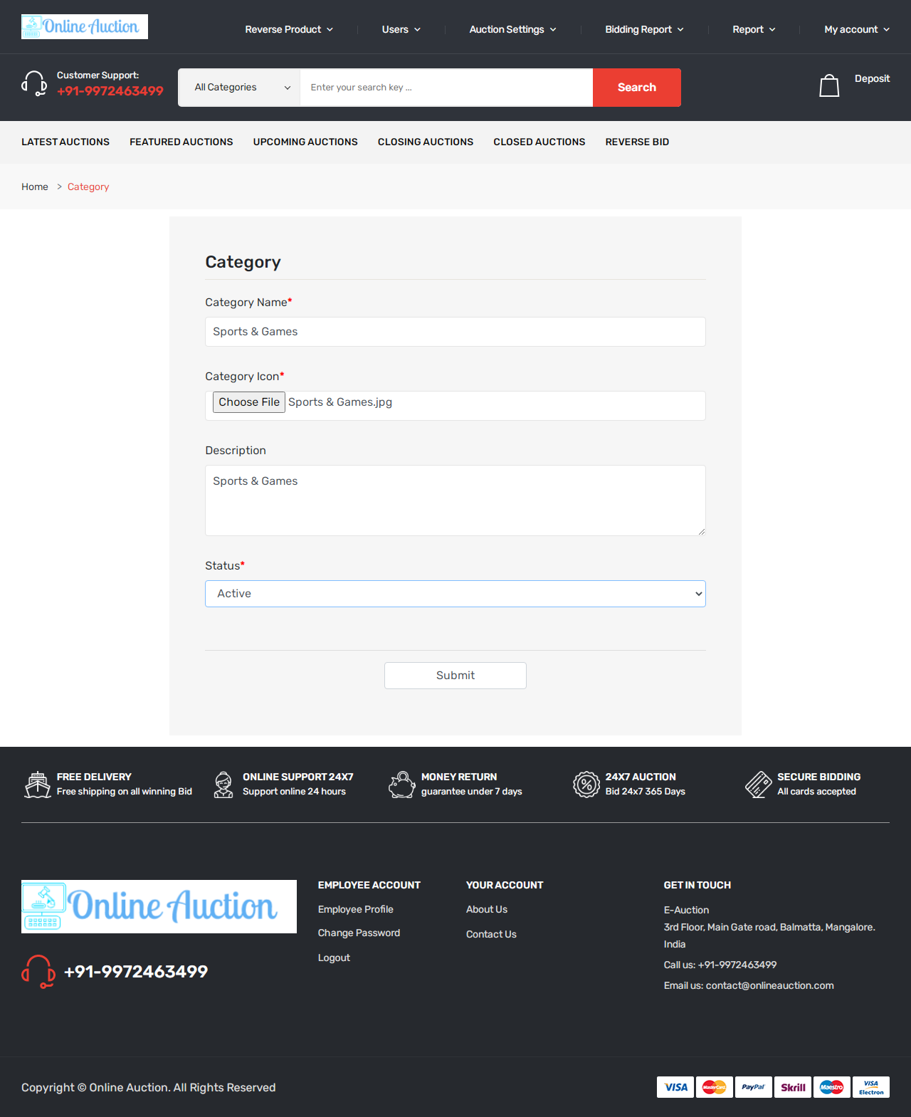

**Add Employee:  
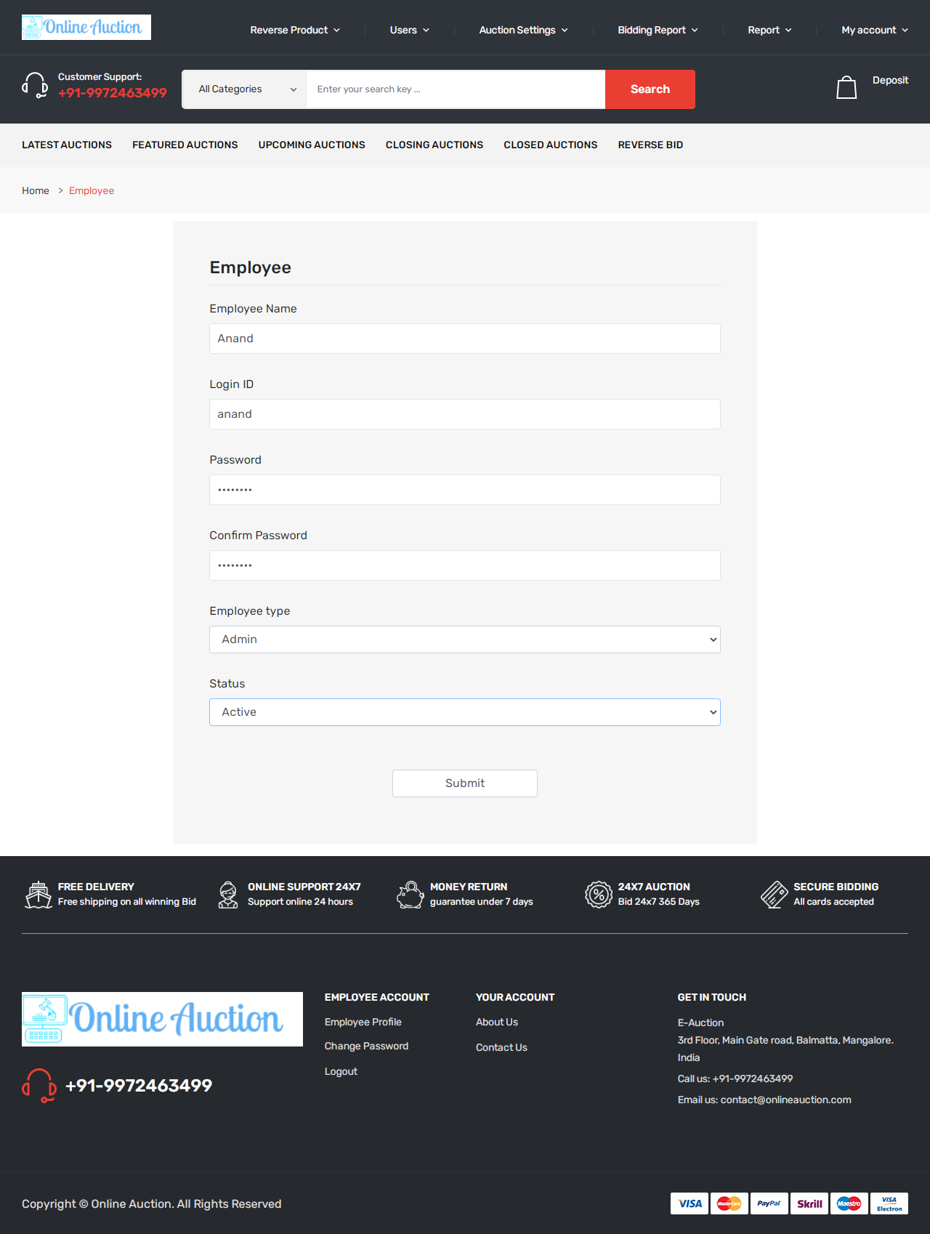**

**Customer - Upload Product:**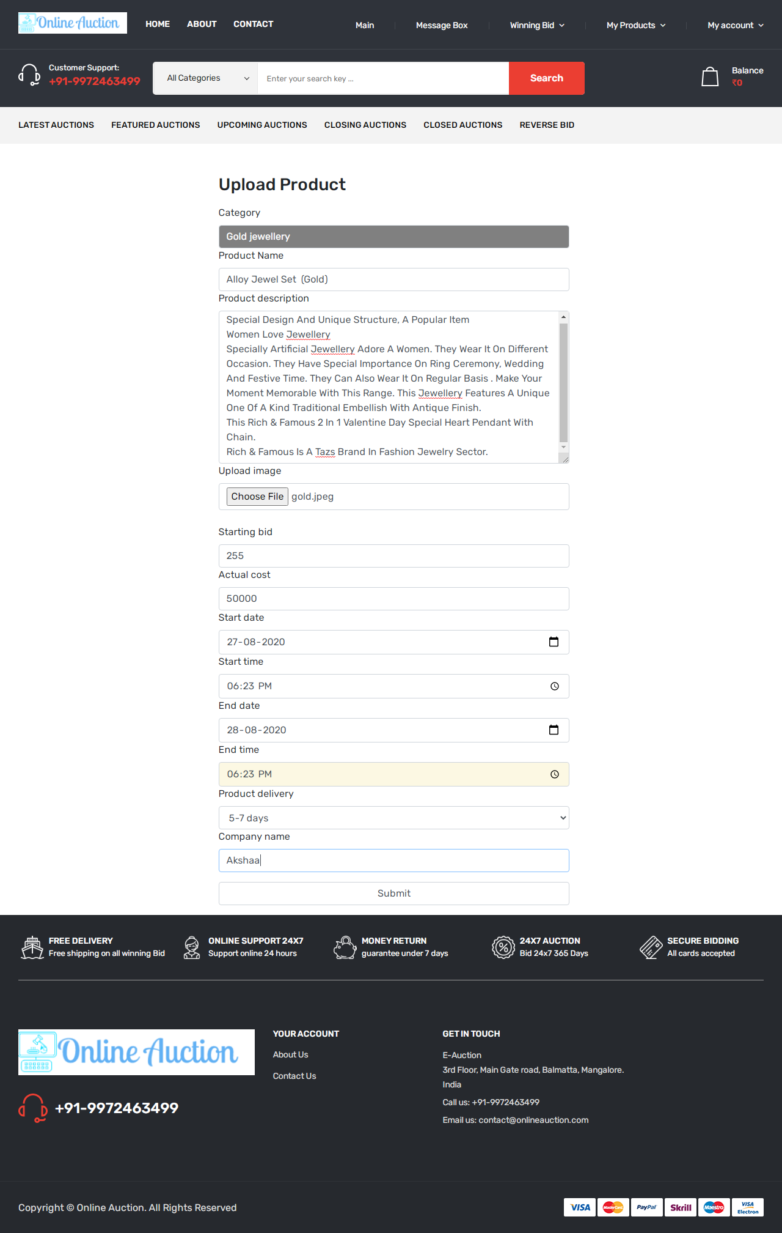

**Admin - Reverse bidding Product**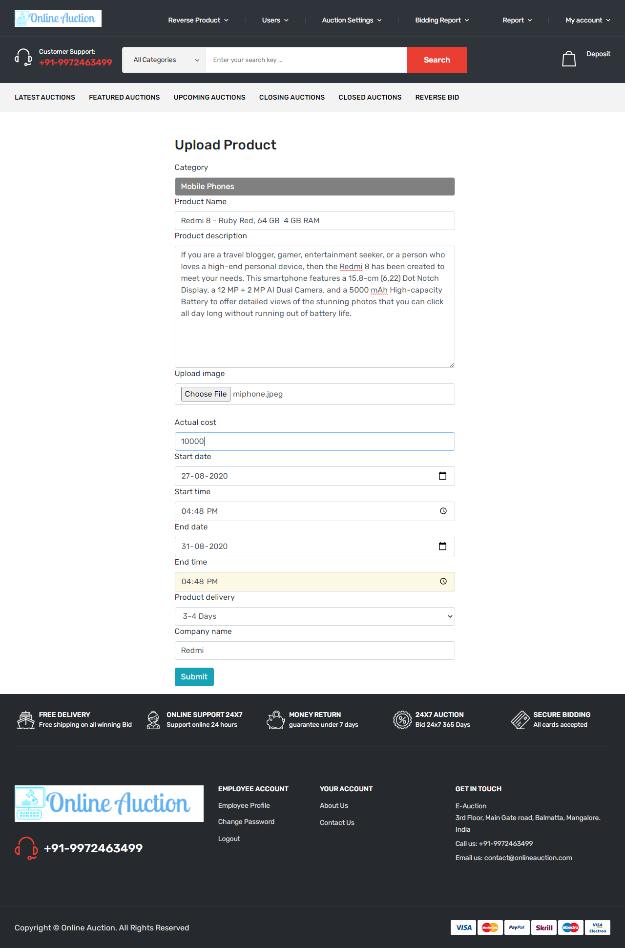

**Admin Dashboard**

**Admin Login :**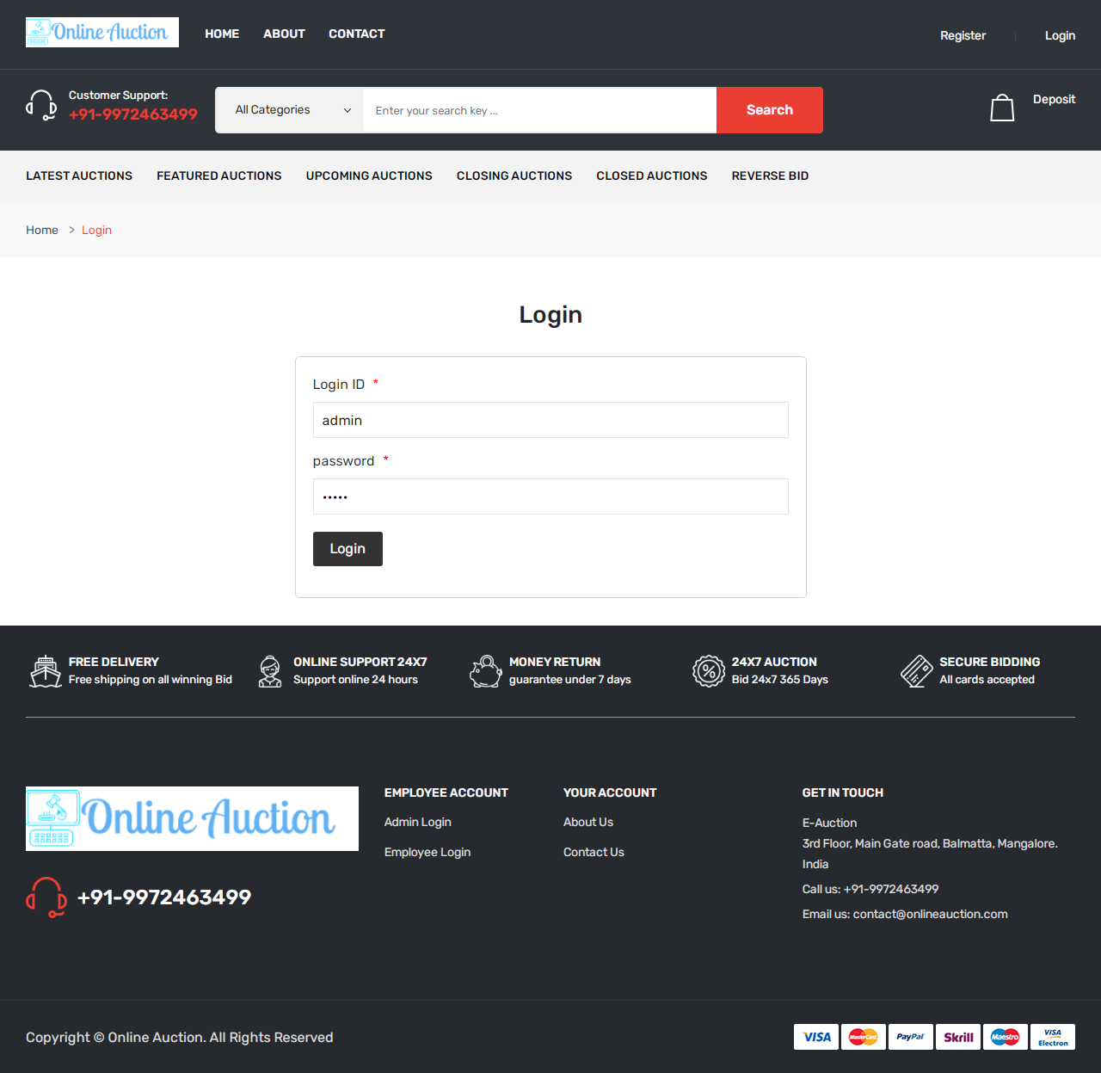

**Bidding Form:  
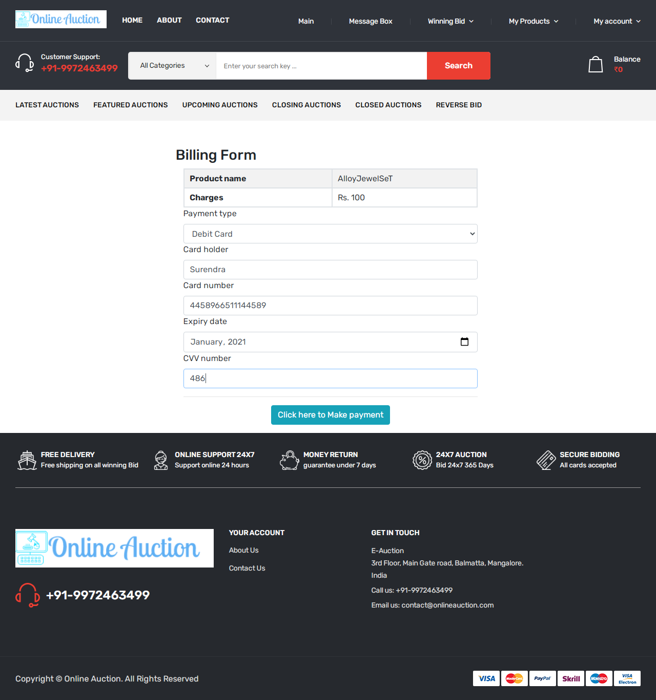Online Chat:**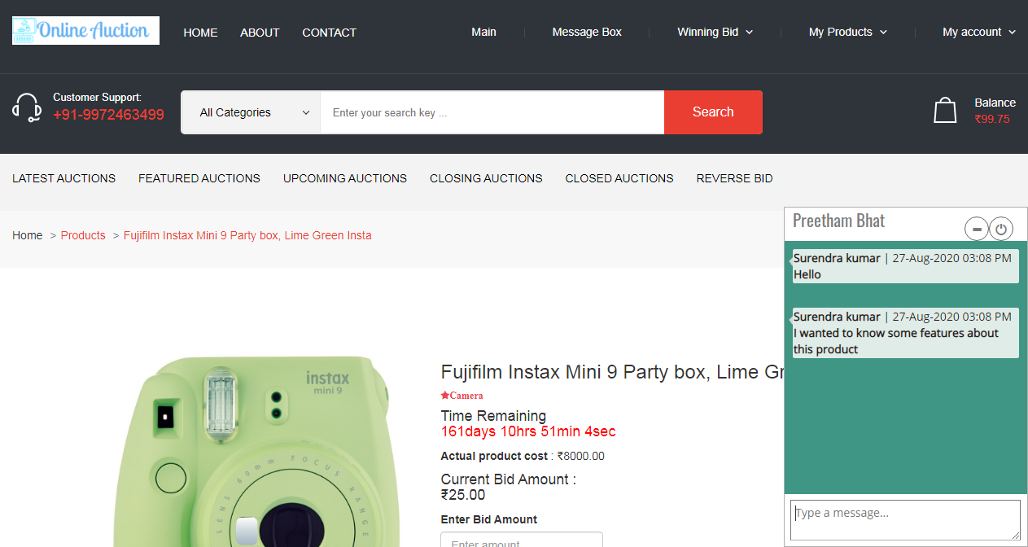

**Customer Login:  
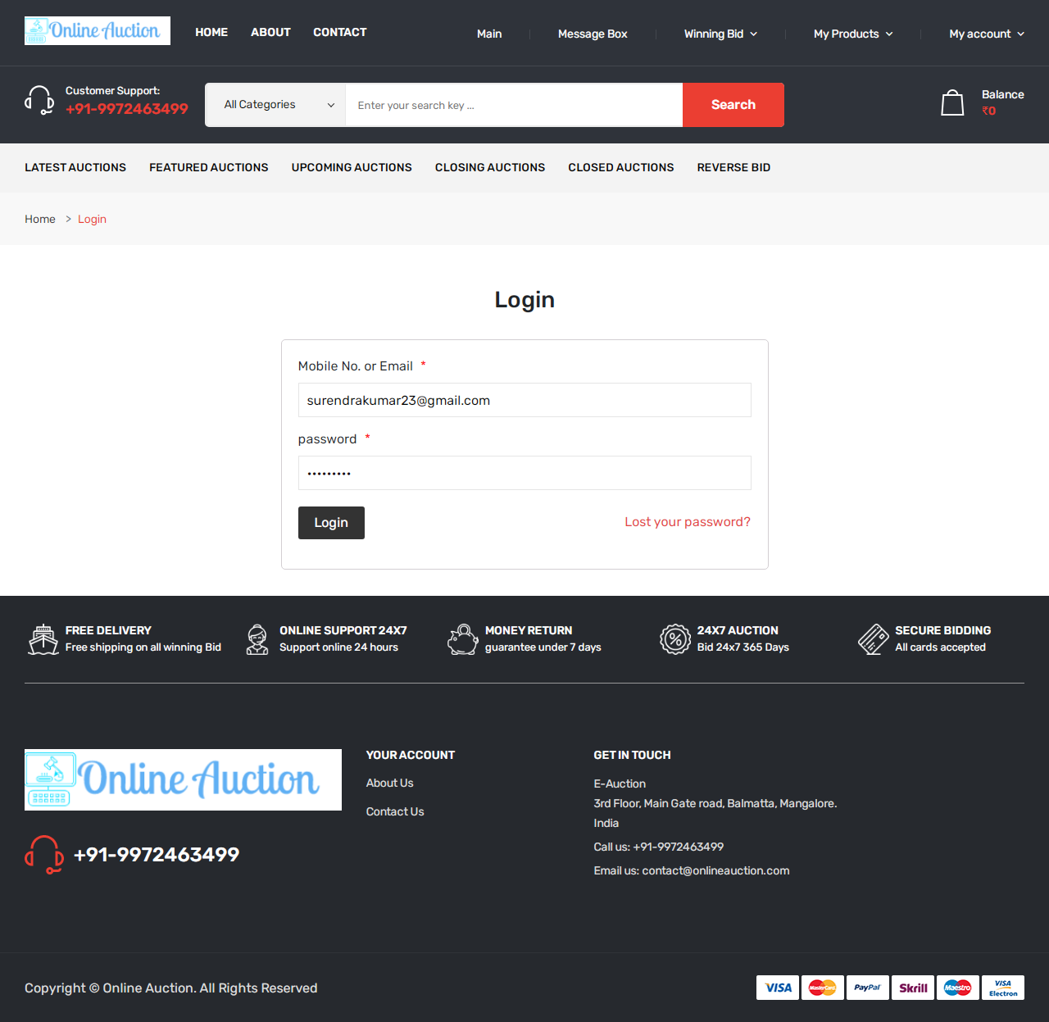**

**Customer Panel:**

**Customer Register**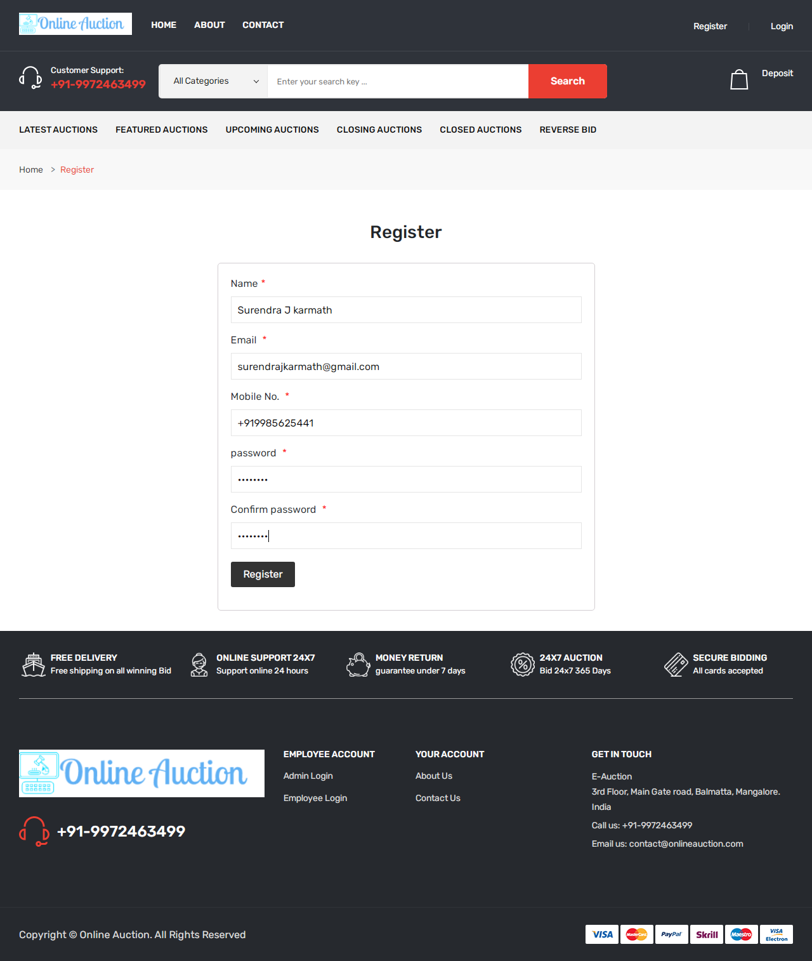

**View Customer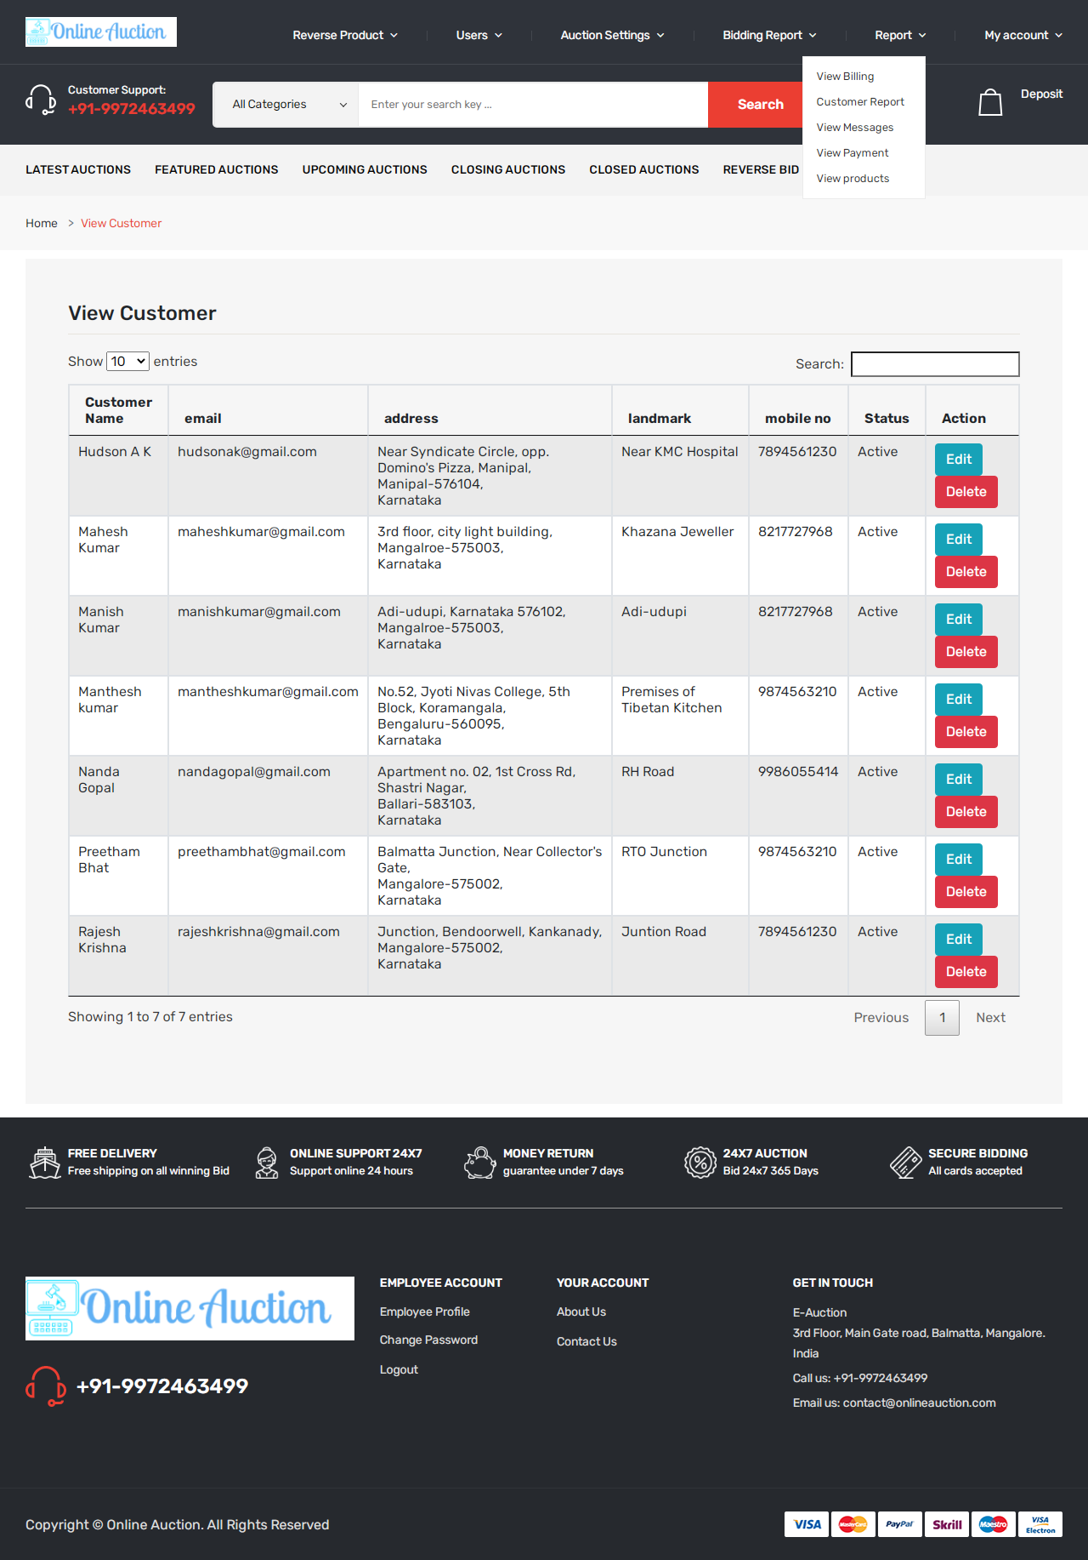Deposit Advance amount for bidding**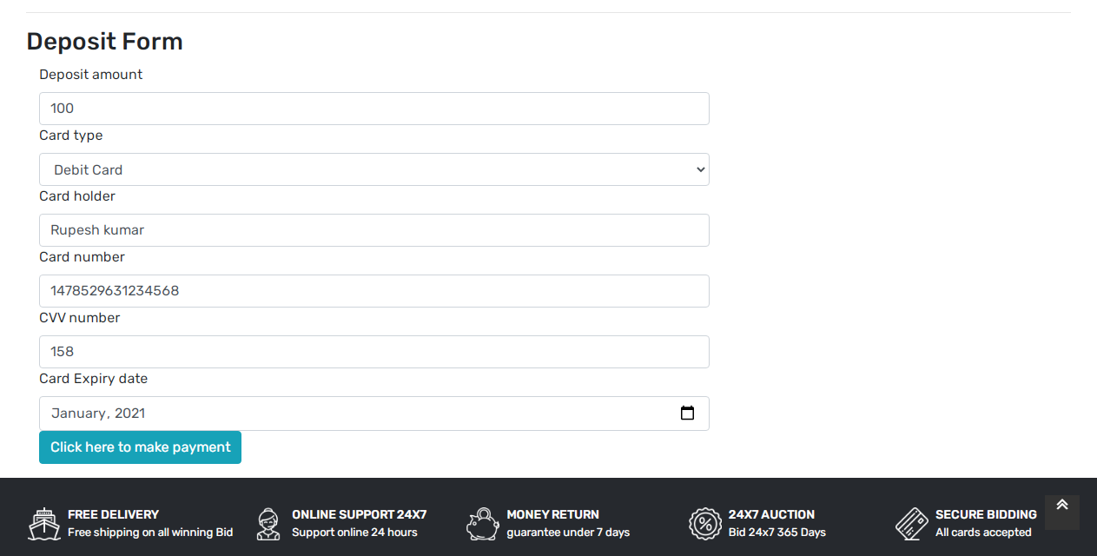

**Payment Receipt**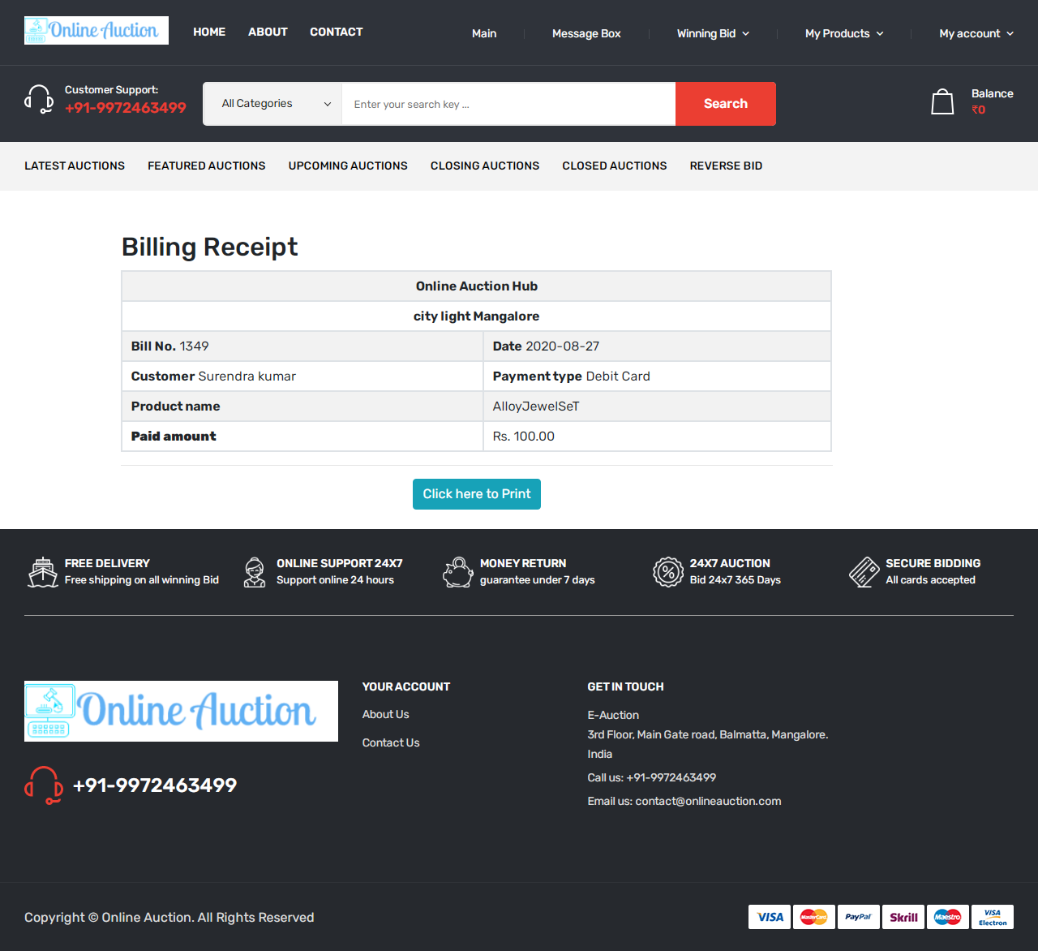

**Bidding Panel**

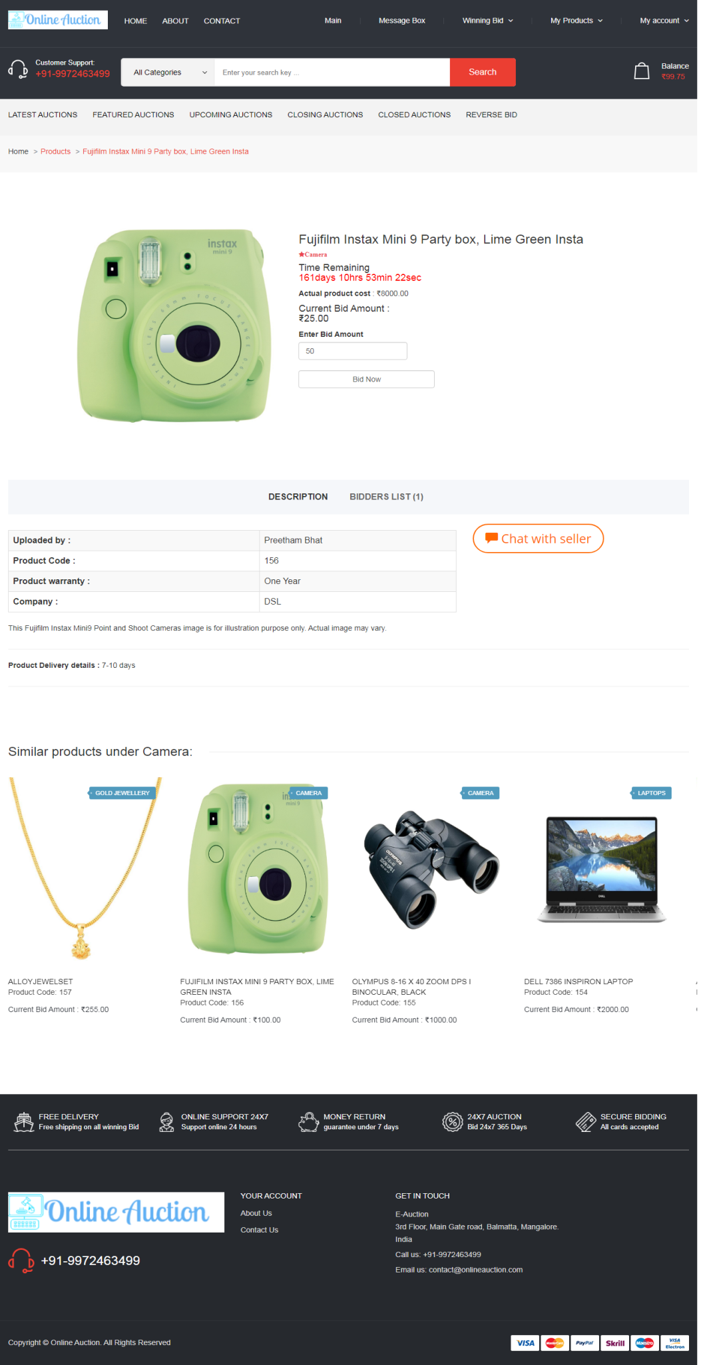

**Select Category to Add product:**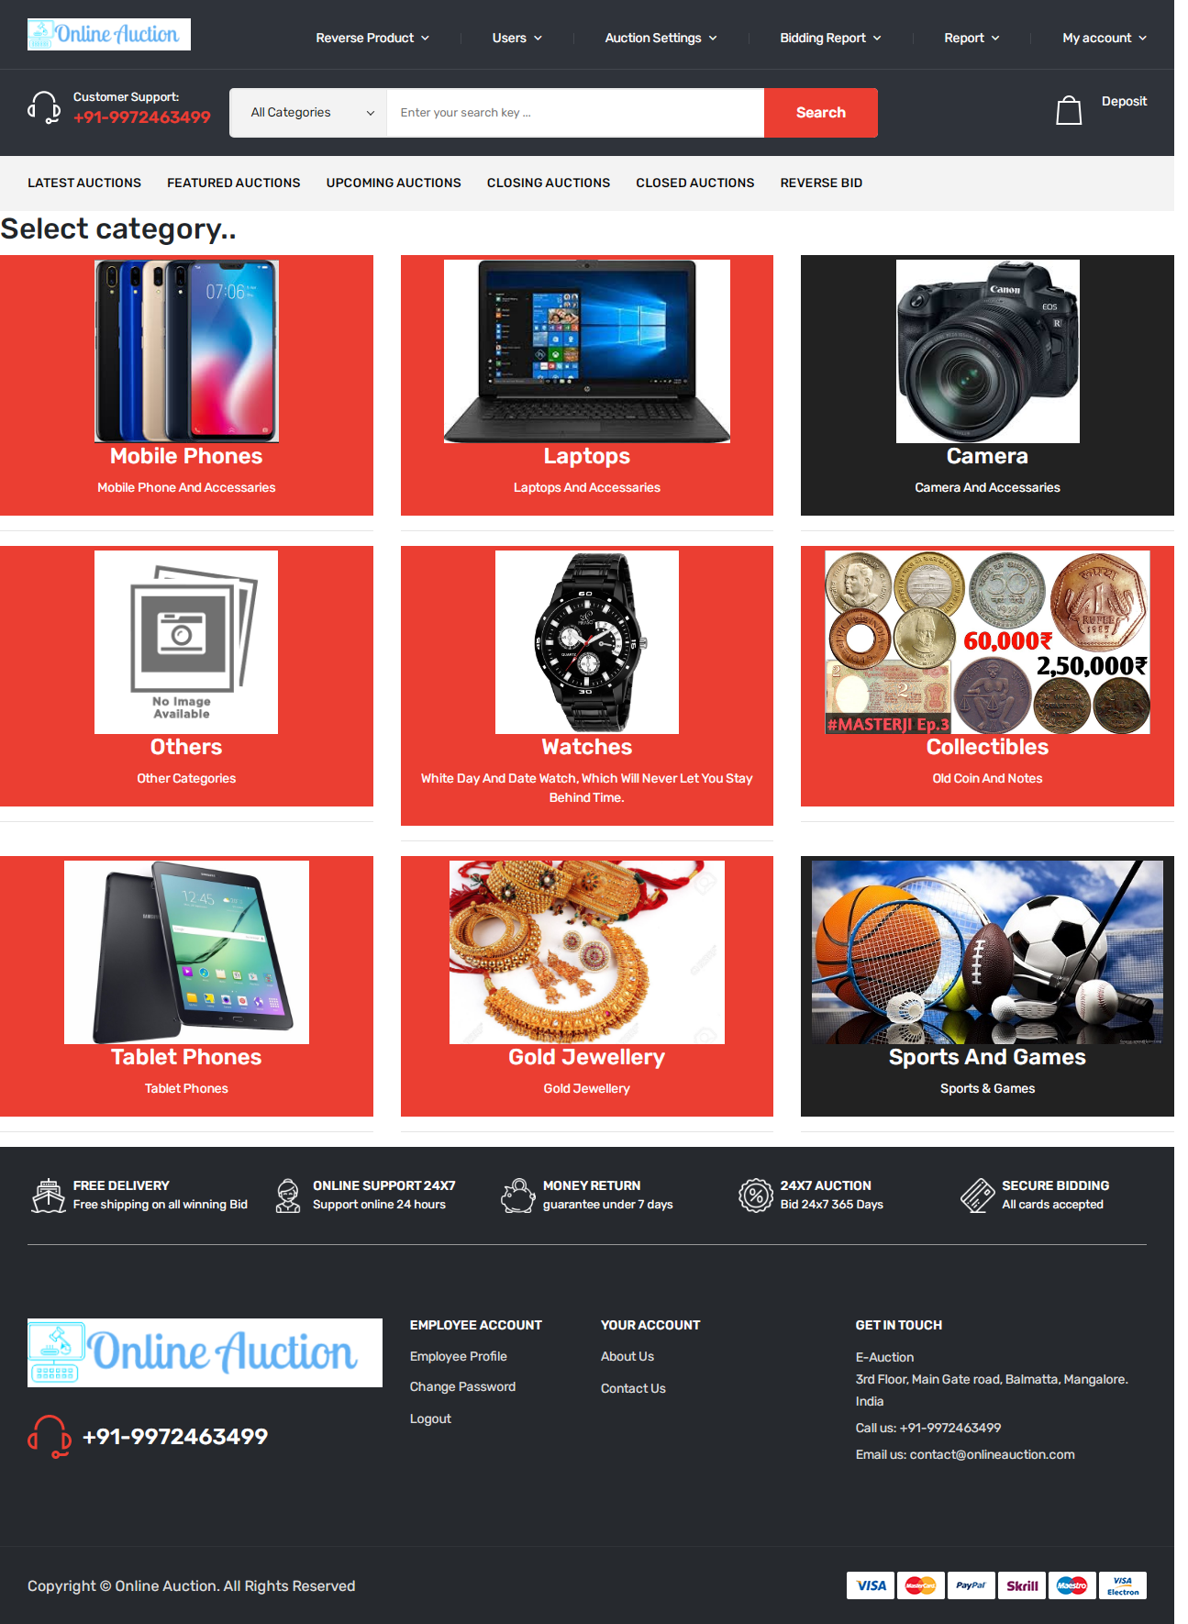

**Latest Auctions  
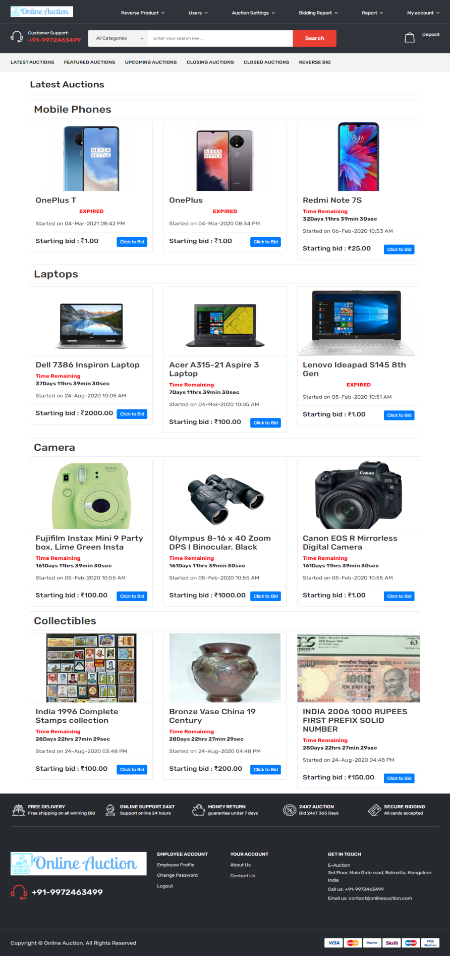**

**Payment Report:**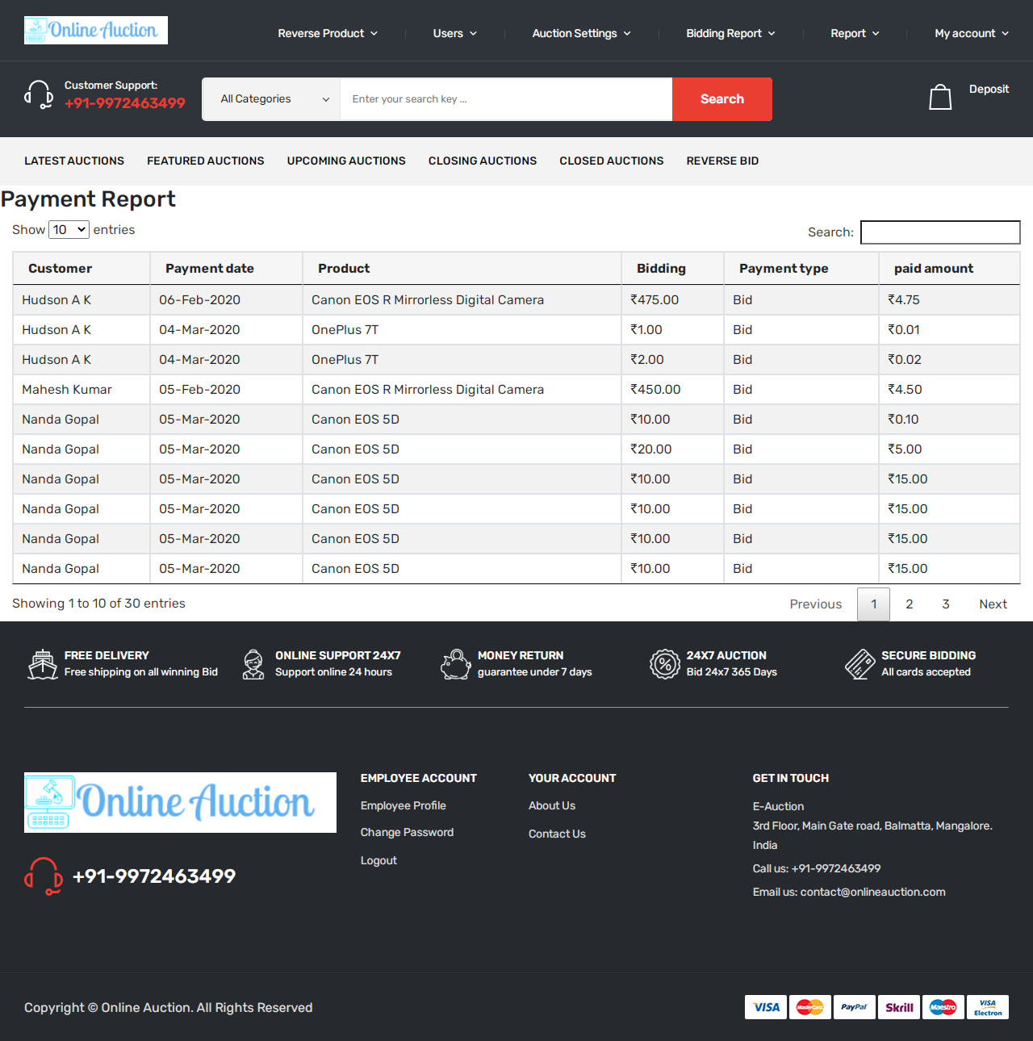

**View Category:  
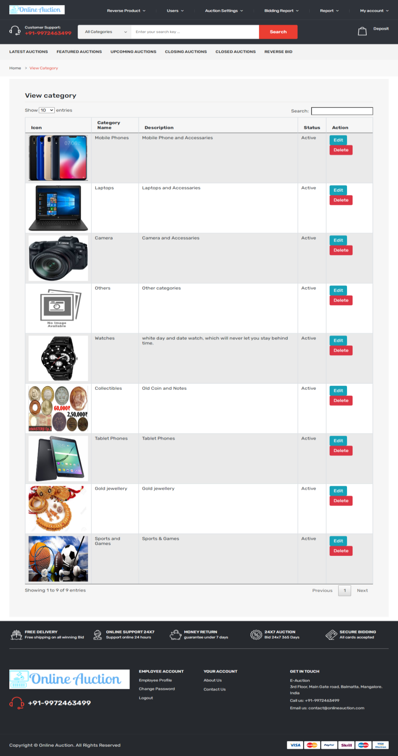**

**View closed Biddings**

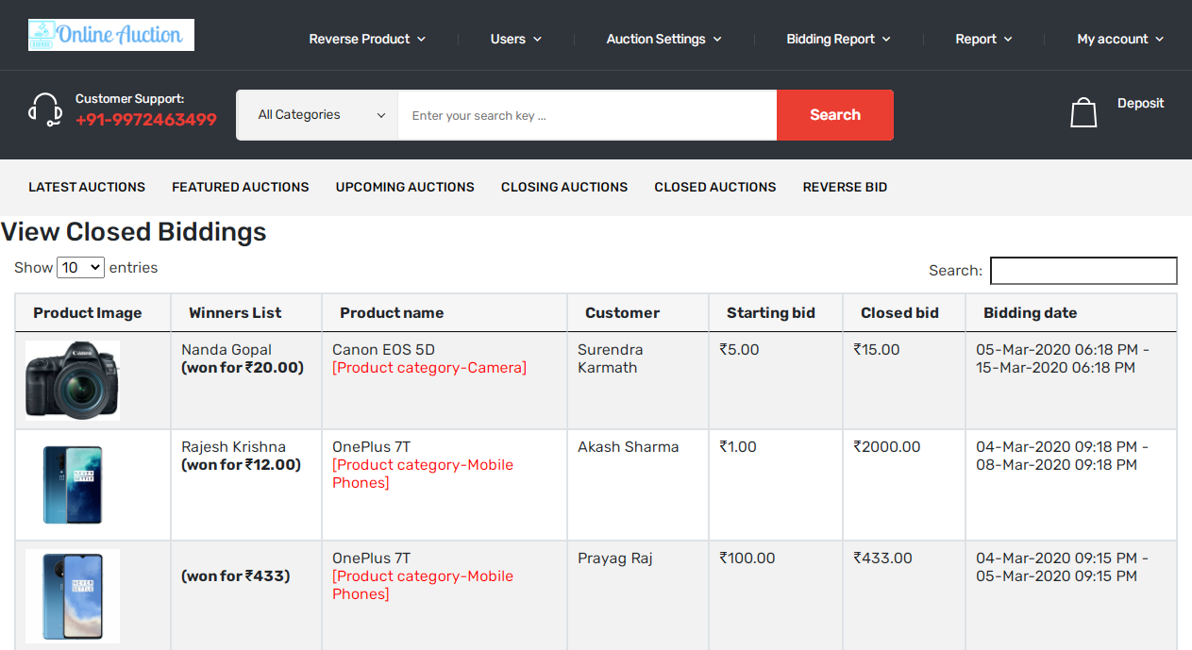

**View Customer**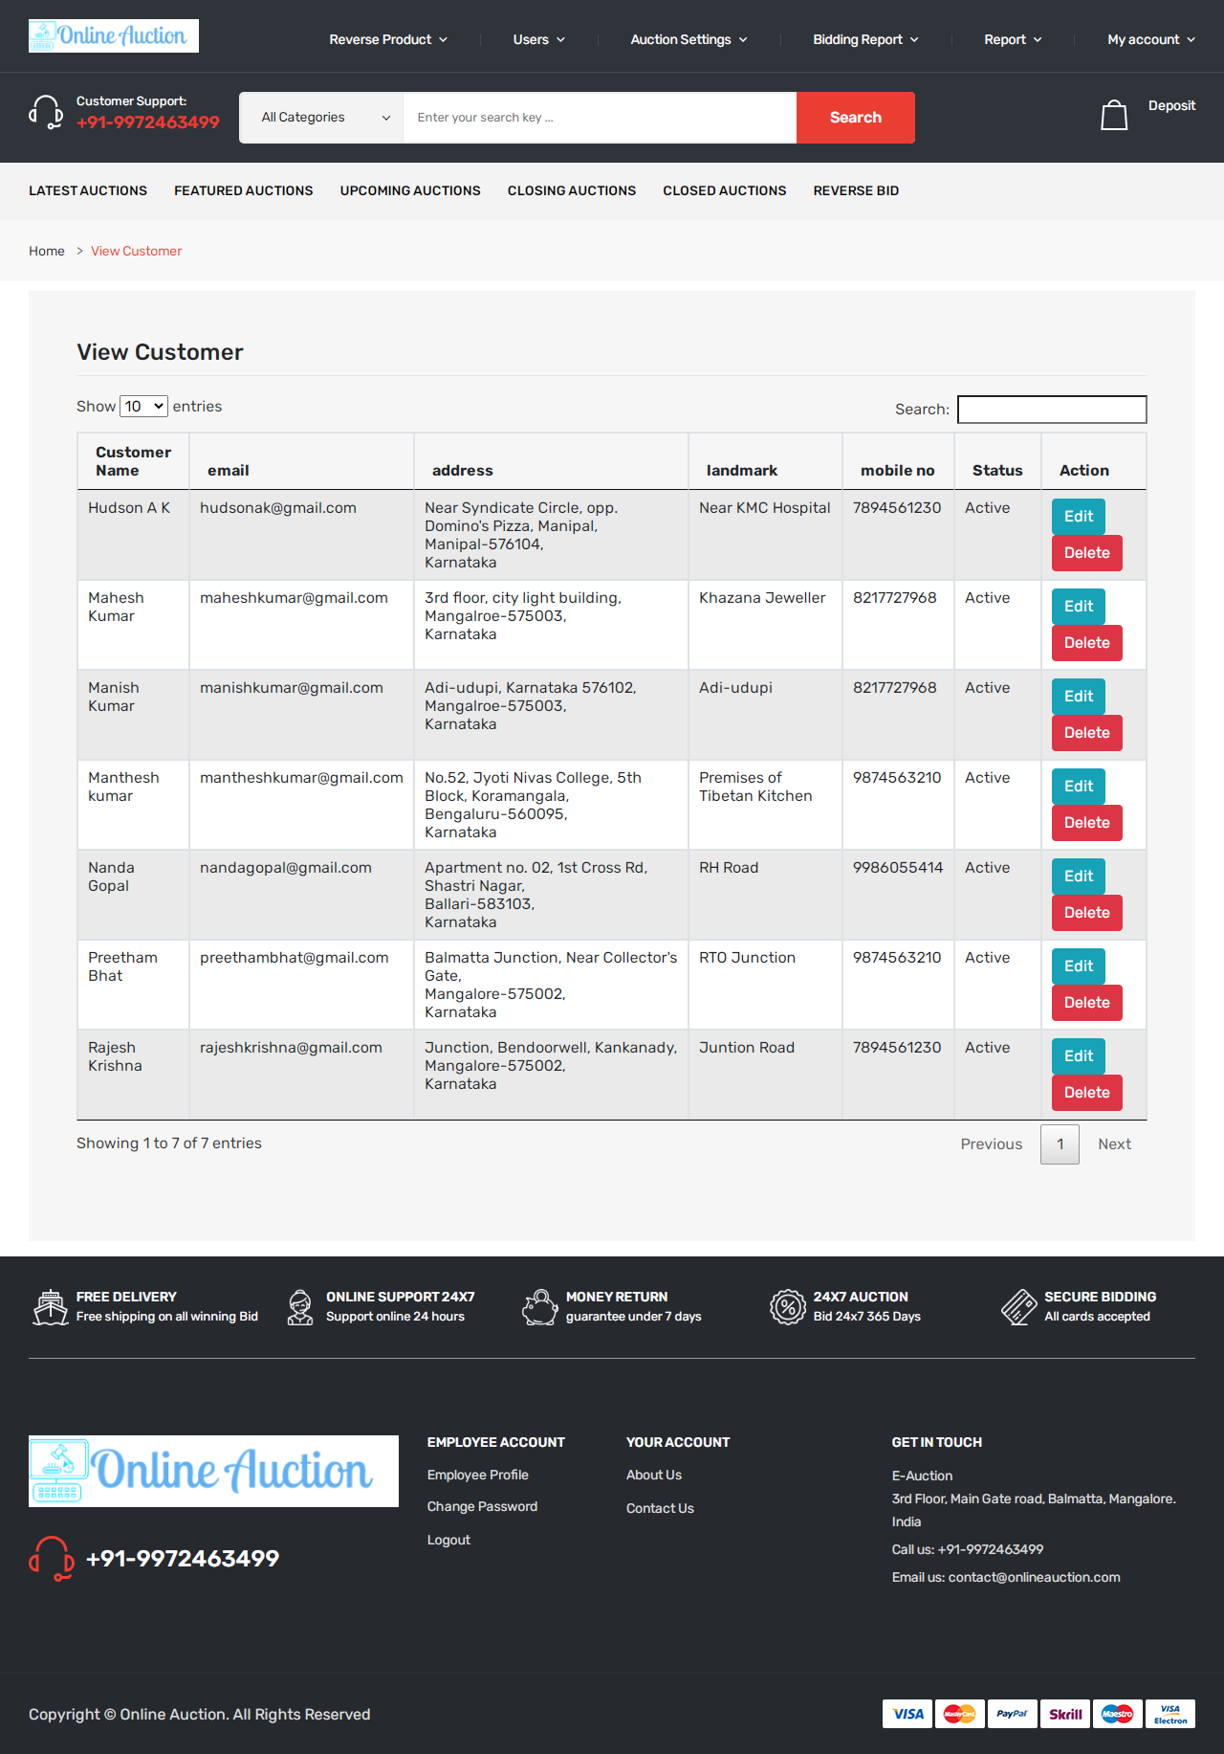

**View Employee**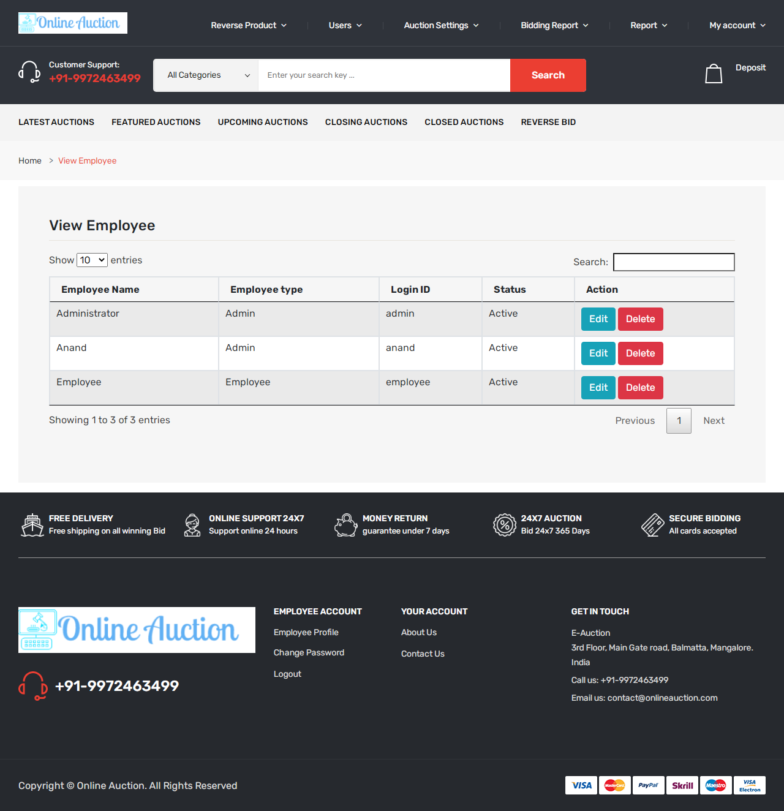

**View transaction Report**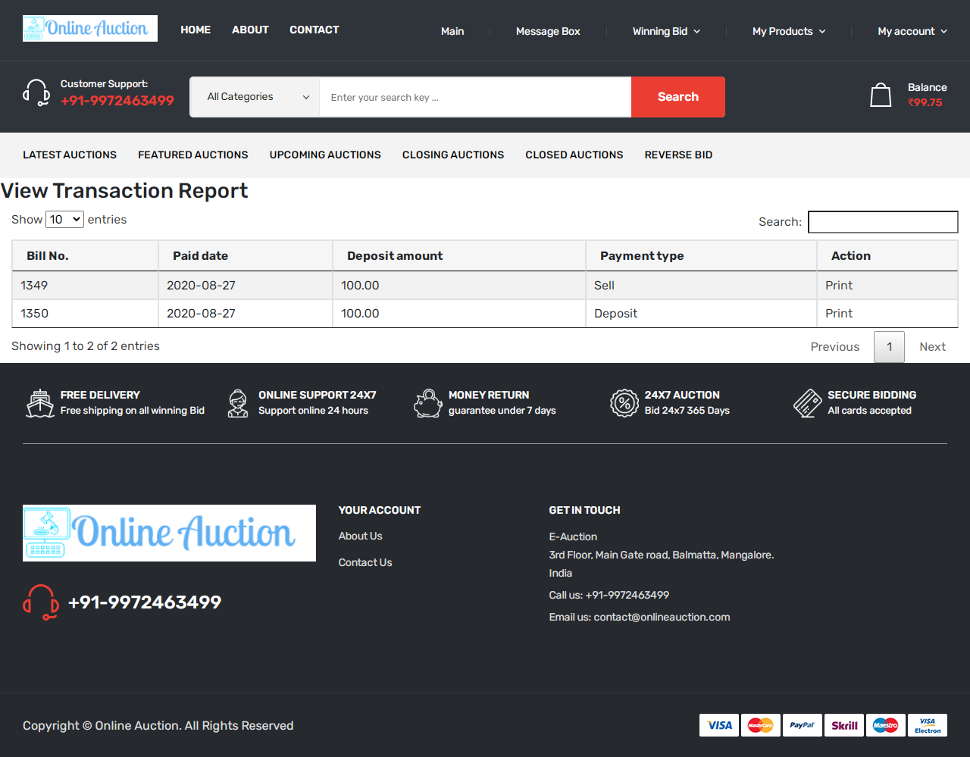

**My bidding List**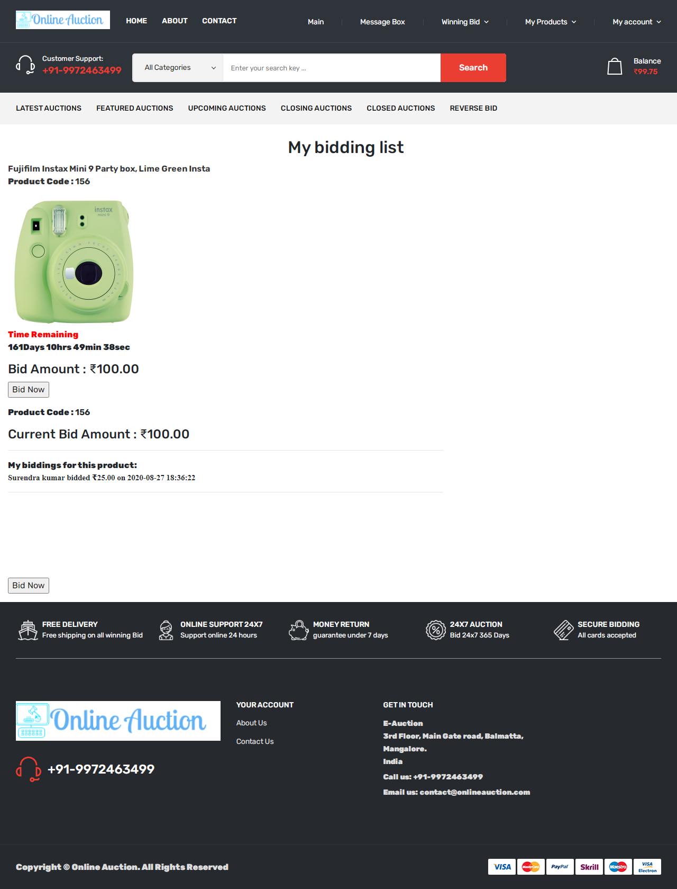

**View Customers**

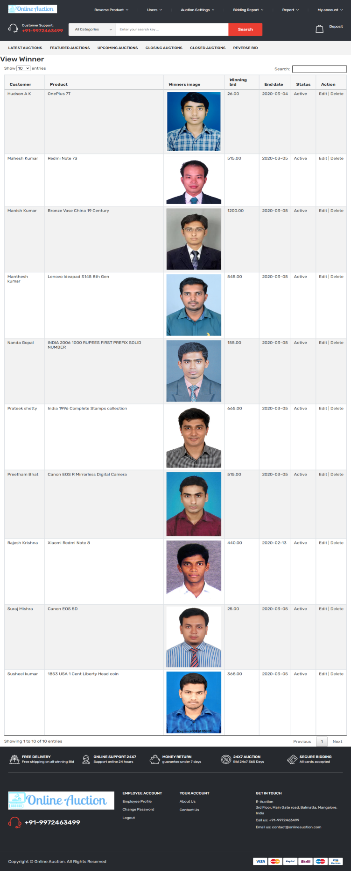

**CHAPTER-9**

**USER MANUAL**

**9.USER MANUAL**

**9.1 INTRODUCTION**

Online Auction is a special website application which allows the customers to bid the amount and purchase the products which he want to buy. The customer need to bid the amount with a given time . After the time gets over the product will be sold to the highest bid done by the customer.

**9.2 Software Interfaces:**

* **Development tool:** PHP : Hypertext Preprocessor, JavaScript, Ajax
* **Scripting server:** Apache server
* **Data Base server:** MySQL
* **IDE:** Adobe Dreamweaver CS 6.0 / Notepad++

**9.3 User classes and characteristics**

* Customer
* Employee

**9.4 Design and implementation constraints:**

The system needs following tables under online auction database:

* Billing
* Bidding
* Category
* Customer
* Employee
* Message
* Payment
* Product
* Winner

**9.5 Functional Requirements:**

**Login/Registration module:** Those who wish to take part in bidding or sell products at the site have to register at the site as customer. Only authenticated users can take part in selling or in bidding. In this module customer can register to the system by entering registration details. After the registration they can login to the system by entering unique login id and password.

This module has following sub modules:

* Login module
* Registration module

**Customer account module:** In the customer account module customer can view his own bidding details, Purchase report, auction winning report, etc. Even the customer can change his password and he can update the password in the account section.

This module has following sub modules:

* Customer account
* Customer profile
* Change password
* Update profile
* View bidding details
* View auction records

**Product list module:** This module allows sellers to add auction products. This collects information like product name, product category, product detail, product image, Start bid, Sale price, Bidding start date and end date from seller.

This module has following sub modules:

* Add product
* Product list module
* Update product

**Category module:** Before uploading product Customer should select category details. In the website product displays under the category list. Only administrator can add category records.

This module has following sub modules:

* Add category
* View category

**Search module:** In this module customer can search for particular products. After searching the system display records in the search list.

This module has following sub modules:

* Search product list
* View product list

**Bidding Module:** In the bidding module customer can bid for products. Customer can select any item and they can bid for the product.

This module has following sub modules:

* Product Bidding module
* View bidders
* View bidding records

**Purchase module:** This module is for winning bids where customer can pay for winning bids. After the payment seller needs to deliver the product to customer.

This module has following sub modules:

* Purchase product
* View purchase detail

**Chat module:** If the customer has any queries regarding product they can directly contact with sellers. 24x7 online chat features available. If the seller is offline then the message stores under seller message box.

This module has following sub modules:

* Compose message
* View sent messages
* View Received messages

**Report module:** This module is for administrator to check sales report, product report, auction report, payment report, etc.

This has following sub modules

* View customers
* View messages
* View bidding items
* View winners list

**Dashboard module:** This dashboard module is for administrator and employees. Admin has full authority of the website and employee has limited authority.

This module has following sub modules:

* View dashboard
* View profile
* Update profile
* Change password

**Settings module:** Here administrator can add employees, categories, website settings, etc.

* Add employees
* View employees
* Add category
* View category

**CHAPTER-10**

**CONCLUSION**

**10.CONCLUSION**

So, from above all elaboration here in short we would say online auction system will give new approaches and dimensions to the auction system .It will encourage both buyers and sellers to participate in auction process. Removes geographical boundaries, location constraints and time constraints.It is a transparent process with no mutual work. Finally, online auction has become other easy solution to the expectation of online buyers since it excludes the need of physical presence of a bidder at the auction place and the product can be obtained at the affordable price. Buyers can buy the product at there own affordable price.

**CHAPTER-11**

**FUTURE ENHANCEMENT**

**11.FUTURE ENHANCEMENT**

The future enhancement to the system can be made as technology improves or changes.

* In future we can integrate this web application with mobile apps.
* We can add gaming bid features in future.
* Currently this system supports India rupee currency. In future upgradation we can add multiple currencies.
* We can Add bidding system for Agriculture produces which helps farmers to sell for best auction price.
* We can add GPS features where buyer can track seller location

**CHAPTER-12**

**BIBLIOGRAPHY**

**12.BIBLIOGRAPHY**

**REFERENCES:**

* www.w3schools.com
* www.tutorialspoint.com
* www.stackoverflow.com
* Web Database Applications with PHP and MySQL By Hugh E. Williams, ‎David Lane
* An integrated approach to Software Engineering By Pankaj Jalote